Estimation of all-cause excess mortality by age-specific mortality patterns for countries with incomplete vital statistics: the case of Peru during the first wave of the COVID-19 pandemic

Lucas Sempé[1]

Peter Lloyd-Sherlock[2]

Ramón Martínez[3]

Shah Ebrahim[4]

Martin McKee[5]

Enrique Acosta[6]

08 June 2021

# Summary

## Background

All-cause excess mortality is a comprehensive measure of the combined direct and indirect effects of COVID-19 on mortality. Estimates are usually derived from Civil Registration and Vital Statistics (CRVS) systems, but these do not include non-registered deaths, which may be affected by changes in vital registration coverage over time.

## Methods

Our analytical framework and empirical strategy account for registered mortality as well as under-registration and registration growth. This provides a better estimate of the actual mortality impact of the first wave of the COVID-19 pandemic in Peru. We use population and crude mortality rate projections from Peru’s National Institute of Statistics and Information (INEI, in Spanish), individual-level registered COVID-19 deaths from the Ministry of Health (MoH) and individual-level registered deaths by region and age since 2017 from the National Electronic Deaths Register (SINADEF, in Spanish).

We develop a novel framework combining different estimates and using quasi-Poisson models to estimate total excess mortality across regions and age groups. Also, we also use logistic mixed-effects models to estimate the coverage of the new SINADEF system.

## Findings

We estimate that registered mortality underestimates national mortality by 24.4% (95% CI 21% - 47.2%) across 26 regions and nine age groups. We estimate total all-cause excess mortality during the period of analysis at 135,557 (95% CI 131,826 - 160,313) of which 108,943 (95% CI 96,507 - 118,261) were captured by the vital registration system. Deaths at age 60 and over accounted for 74% (95% CI 73.6% - 74.5%) of total excess deaths, and there were fewer deaths than expected in younger age groups. Lima region, on the Pacific coast and including the national capital, accounts for the highest share of excess deaths, 65,283 (95% CI 65,215 - 73,320), while in the opposite side regions of Apurimac and Huancavelica account for less than 300 excess deaths.

## Interpretation

Estimating excess mortality in low- and middle-income countries (LMICs) such as Peru must take under-registration of mortality into account. Combining demographic trends with data from administrative registries reduces uncertainty and measurement errors. In countries like Peru, this is likely to produce significantly higher estimates of excess mortality than studies that do not take these effects into account.

## Funding

None.

# Research in context

## Evidence before this study

We searched PubMed, Google Scholar, medRxiv, and SocArXiv for studies published up to May 27, 2020, using the keywords “excess mortality” and “under-registration” or “sub registration,” combined with “coronavirus” or “SARS-CoV-2” or “COVID-19.” We found studies estimating cumulative mortality in high-income countries in Europe and North America solely based on official death counts. We found studies computing overall COVID-19 mortality for a small number of LMICs. Prior research shows a significant percentage of under-registration of deaths in LMICs.

## Added-value of this study

To our knowledge, we provide the first estimate of excess mortality associated with COVID-19 in a LMIC that accounts for both registered and unregistered deaths. We develop an analytical strategy to address common challenges faced by LMICs, such as low completion rates of death certificates, missing data, vital registration growth, and inconsistency and variability of data across regions and age groups. We show our method is robust for small samples, including for subnational regions and specific age groups.

## Implications of all the available evidence

Our approach shows the importance of accounting for unregistered deaths based on demographic trends to generate robust estimates of excess mortality associated with COVID-19. It suggests that previous reports of COVID-19 related mortality in Peru were substantial underestimates.

# Introduction

Monitoring mortality is an essential part of the public health response to the COVID-19 pandemic. In many countries, COVID-19 mortality monitoring has been hindered by failures to capture all deaths or to accurately attribute cause of death.1 Disentangling the contribution of COVID-19 to overall mortality is especially challenging, as many people who die from COVID-19 have other conditions, such as cardiovascular disease and diabetes.2Some countries apply different cut-off times between a positive COVID-19 test and death, when attributing mortality to this cause.3 Also, the pandemic has led to large numbers of deaths not directly attributable to COVID-19 (either exclusively or in part), due to effects including reduced access to treatment for other conditions.4,5 Conversely, there is evidence that lockdowns have sometimes reduced expected rates of mortality from causes such as road traffic injuries and homicides.6,7

In the absence of good data on these different effects, robust estimation of all-cause excess mortality offers the most complete and reliable approach for gauging the overall impact of the pandemic in a defined population over a fixed period.8 Excess mortality refers to the number of additional deaths occurring over a time period when specific conditions apply (in this case, the presence of COVID-19), compared to the number of deaths we might reasonably expect over the same period based on historical data. It captures deaths directly attributed to COVID-19 and those resulting from other consequences of the pandemic, to provide an estimate of the overall mortality effect.9

Excess mortality estimates based on registered deaths have been computed for high-income countries by surveillance agencies,10,11 academia12–15 and the media.16–19 However, these data are often incomplete or inaccurate, especially in many low and middle-income countries (LMICs). The Global Burden Disease (GBD) estimates only 64% of global deaths were registered in 2015.20 In most LMICs, responsibility for mortality data is divided between different national and subnational agencies.21 This can cause extended delays in national reporting and discrepancies between different sources.13,22 Disaggregation of summary data by different geographical areas or demographic groups is usually very limited.23 These shortcomings explain the lack of published studies of excess mortality in LMICs.23,24

We analyse excess mortality associated with the COVID-19 pandemic in Peru during 2020, a country that suffered in 2020 one of the highest excess death rates in the world. Multiple explanations could be made such as poor health investment, complex geographies and high poverty rates and informal employment.25 This country is well-suited to our analytical approach for various reasons. Peru shows significant geographic and population diversity and is distributed in three natural regions: a narrow and populated dry coast, the Andean region and a large rainforest region to the east, which is the less densely populated, divided into 26 higher-level administrative areas, called regions. Like much of Latin America, Peru has experienced high levels of COVID-19 mortality, with certain areas showing high rates of seroprevalence of anti-SARS-CoV-2 antibodies such as the capital city Lima26 and extremely high rates in Iquitos (in Amazonia).27 Official sources report 36,036 deaths directly caused by COVID-19 between 18 March and December 31 2020. However, these only include cases with positive COVID-19 test results and rates of testing in Peru have been low compared to other Latin American countries.28 Also, many tests have used low sensitivity devices, potentially generating false negatives . On the other hand, Peru does place anonymised individual-level data on mortality and COVID-19 in the public domain.29

We deploy a specific array of analytical tools to address these issues and apply them to the case of Peru during the first wave of the pandemic. Between 18 March and December 31 2020, the country reported 37,725 deaths directly caused by COVID-19. This official figure only includes cases with positive COVID-19 test results, but rates of testing in Peru have been low compared to other Latin American countries,28 and many tests have used low sensitivity devices, potentially generating false negatives.30 A recent governmental-based study which applies a wider set of indirect criteria to identify “probable COVID-19 deaths” estimates 90,000 deaths potentially attributable to the condition occurred over a similar period.31 This study applies a unique and controversial methodology: for example, it categorises any death in households where at least one person tested positive for COVID-19 as potential COVID-19 deaths even if the dead person was not tested.

Given the level of uncertainty about COVID-19 mortality in Peru, estimates of excess all-cause deaths offer a more instructive indicator of the pandemic’s impact. However, substantial gaps in death registration represent a barrier to producing robust estimates. Studies from other LMICs show registration coverage often varies significantly between sub-regions and age groups.32,33 Peru is a geographically diverse country (Figure 1), but does not report registration rates at these levels, hindering analysis of geographical and age patterns. In 2017, Peru implemented a new online register with increasing coverage over time although lower than the manual system.34 Consequently, comparisons over time must take increased registration into account.

[FIGURE 1 ABOUT HERE]

To resolve these challenges we develop an analytical framework and empirical strategy, which deal with both registered and unregistered mortality, changes in registration coverage over time and variations in coverage between regions and age groups. This adds value to the methods applied by other studies of excess mortality, which focus exclusively on registered deaths.32–34 We test the feasibility of this method by applying it to Peru during 2020 in order to assess its more general suitability for LMICs with similar gaps and inconsistencies in mortality registration.

# Data and methods

## Data

We use data from two Ministry of Health (MoH) mortality registration systems. Anonymised individual-level registered deaths from the National Electronic Deaths Register (SINADEF, in Spanish) from 2017 to 2020 are divided into 26 regions and 9 age groups. In 2017 Peru shifted from a paper-based system to an electronic one, which led to a growth in coverage (from 98,552 in 2017 to 114,449 in 2019). However, coverage remains unequal among regions,29 impeding comparisons of spatial and temporal trends. Additionally, we use anonymised individual-level registered deaths by region and age group from MoH COVID-19 tracking systems. Both sets of data include day of death, age, sex, day of birth and administrative region was collected on May 30 2021. Table 1 summarises the main descriptive statistics for the SINADEF and COVID-19 databases. We also use population and mortality projections for recent years, by region and age group, from Peru’s National Institute of Statistics and Information (INEI, in Spanish). These projections are based on decennial censuses (the most recent in 2017) and annual health and population surveys.35

[TABLE 1 ABOUT HERE]

Figure 2 shows weekly registered deaths by region for 2017 to 2020. All regions, other than Apurimac, saw an initial peak at some point between week 20 to week 40. All regions then saw significant declines, although a second peak occurred in Lima and Pasco in weeks 50 to 52.

[FIGURE 2 ABOUT HERE]

## Excess mortality methods

Figure 3 presents our approach to estimate excess mortality. This can be decomposed into four terms: (i) SINADEF registration growth rate (ii) excess SINADEF registered deaths; (iii) excess unregistered deaths; and (iv) unregistered COVID-19 deaths. While the terms (ii)-(iv) add positive counts towards the final estimate of total excess deaths, the first term adjusts the final estimate downwards. Figure 4 summarises our empirical strategy based on data sources used (squares), statistical analysis performed (diamonds) and outputs (circles).

[FIGURE 3 ABOUT HERE]

[FIGURE 4 ABOUT HERE]

Average weekly mortality in the period between the first and second waves was higher than before the pandemic. This probably reflected continued occurrence of some COVID-19 deaths and increased coverage of the registration system. To address this, we define start and end points for the pandemic36, using 0.60% as a threshold criterion of weekly change and assuming a linear registration growth rate during the first wave (vertical lines in Figure 3). These thresholds are used to estimate our first term, SINADEF registration growth rate.

The first term, SINADEF registration growth rate --, is computed for each region and age group by comparing average mortality from 2018 previous to the pandemic starting point for each region, , and for after the first pandemic wave, adjusted by the number of deaths registered as caused by COVID-19, , as follows:

To estimate the second term, excess SINADEF registered deaths - -, we first fit quasi-Poisson regressions to address the over-dispersed nature of the data to weekly deaths, , as follows:

where we fit a natural cubic B-spline function on weeks to address long-term trends and seasonality.37 Additionally, we use lagged residuals and the log of the population in 2020, as an offset. Finally, we compute a dichotomous variable starting in the week corresponding to the pandemic onset for each region (Figure 2). We calculate the relative risk of those under a statistical significance threshold (p<.05) to compute excess registered mortality as a population attributable fraction (PAF),38 as follows:

where is the weekly number of deaths39 and represents a fraction of the total mortality of the period where in equation (2).

The third term, excess unregistered deaths - -, estimates mortality delayed or absent in official registers and is computed as a fraction of . We start by predicting SINADEF completeness by modelling random-effects logistic regressions40 for each region using data from 2017 and 2019, represented by . We exploit variability in INEI mortality rates, population aged 60 years and over and rurality to address potential differences in terms of registration completeness, using the equation:

where and are the Crude Death Rates, is registration coverage rate for infants -as a relevant proxy measure of overall mortality in a population-,40 is the logarithm under-five mortality rate and represents the fraction of the population at 60 years and over based on INEI projections. is the share of households that use liquefied petroleum gas for cooking. This is an acceptable proxy for rurality in Peru, as 81.8% of rural households primarily use solid fuel compared to 9.8% of urban, ones who typically cook with LPG.41 Rurality is an important factor to explain delay and under-registration of deaths as the system requires access to internet and computers. Additionally, is the error term and is the region-level random effect. is computed using the inverse logit of the predicted values, which provides a regionally adjusted SINADEF completeness rate.

Finally, excess unregistered deaths is based on from equation (1), from equation (3),

and from equation (4), as follows:

The last term, unregistered COVID-19 deaths, , is computed to correct for situations where the proportion of cumulative cases of reported COVID-19 deaths for that period exceeds SINADEF values. This occurs mostly in younger age groups. The calculation is conditional on excess registered deaths being lower than officially registered COVID-19 deaths for each region and specific age group as follows:

Finally, we estimate total excess deaths for different scenarios.

A first scenario is when there is no solid evidence suggesting under-registration of deaths for some regions or age groups and, therefore, no scope to expand registration over time. This usually occurs in areas and age groups with very small populations. In those cases is set to 0 to avoid adding negative values to the sum. A second scenario relates to younger age groups who in some regions have not been significantly affected by COVID-19 mortality. This case occurs when in equation (2) is not statistically significant and therefore we set . A third scenario is when some groups have fewer deaths than expected, due to effects such as reduced road traffic injuries. In these groups and are included in the final estimate. A fourth scenario is when models underestimate the official number of deaths such as . In this case, we use the former as registered deaths. Equation (7) summarises the estimation of as follows:

Finally, we estimate total mortality during 2020 by adding from equation (7) and SINADEF expected deaths for 2020, , adjusted by from equation (5), as follows:

To address the relative level of mortality in 2020, we compute all-cause age-standardised death rates per 1,000 people derived from the estimated total excess deaths. We apply direct standardization methods42 using INEI population estimates by region and age group for 2020 as the standard population.43

As a robustness check for excess mortality estimates, we estimate a mortality baseline for each age group fitting either a Generalised Linear Model with Poisson or Negative binomial distributions, depending on the data’s over-dispersion. The model includes natural splines and sinusoidal components to account for secular changes and seasonality in mortality, as well as interpolated weekly exposures to control for changes in age structure over time. 95% prediction intervals were estimated using 2,000 bootstrapping iterations. Excess mortality is computed as the difference between observed mortality and the baseline, only including weeks in which observed mortality was above the upper prediction interval.

# Results

Between the periods before and after the first wave, SINADEF registration increased by 1.47% across all regions and age groups. Figure 5 shows specific rates for age groups and regions. The age group 0-9 shows negative growth, having also below historical levels of mortality during the pandemic (Table 3). All other age groups have positive growth rates, with higher values for age range 60 to 79. Three regions (Lambayeque, Tacna and Amazonas) had negative median growth rates for all age groups. Greater variance is found in the sparsely populated Andean region of Apurimac. Positive and negative outliers for both age group and region are cases where mortality was very low and therefore sensitive to small changes.

[FIGURE 5 ABOUT HERE]

Estimates of completeness of SINADEF registration derived from our logistic regression model fit the data according to marginal and conditional and Root Mean Square of Errors parameters. Model fit and goodness-of-fit are presented in Appendix 1. Figure 6 shows important variations in regional completeness rates: Amazonas and Loreto (in Amazonia), Lambayeque (on the coast), and Cajamarca (in the Andes) show estimated completion at below 40%, while Ica (coast) and Madre De Dios (Peru’s least populated region in Amazonia) appear to have complete registration (Appendix 1).

[FIGURE 6 ABOUT HERE]

Figure 7 shows observed and predicted values for excess registered mortality by age group and region. These values show both seasonality and growth. This, along with the high number of statistically significant parameters across regressions, indicates the model fits the data. As such, the variable COVID-19 correctly identifies a significant change in mortality patterns across time. See Appendix 1 for statistics and goodness-of-fit analysis.

[FIGURE 7 ABOUT HERE]

Table 2 summarises our estimates of excess mortality. Excess registered mortality is estimated to be 108,943 (95% CI 96,507 - 118,261), of which 37,725 are reported as COVID-19 deaths. See Appendix 1 for results and comparison with robustness analysis.

[TABLE 2 ABOUT HERE]

Table 3 shows estimates by region. Lima, which includes the capital, accounts for 65,283 (95% CI 65,215 – 73,320) total excess deaths, and Apurimac and Huancavelica show the lowest numbers. Table 4 shows excess mortality estimates by age group. Deaths among people aged 60 years and over account for 74% of total excess mortality. There was negative excess registered mortality for the youngest age groups.

[TABLE 3 ABOUT HERE]

[TABLE 4 ABOUT HERE]

Excess unregistered mortality is estimated to be 25,391 deaths (95% CI 40,830 - 34,097), making up 24.4% (95% CI 15% - 40.5%) of our estimate of total registered and unregistered deaths. Coastal regions have the highest values, with Lima accounting for 14,359 additional deaths, followed by Piura (3,017) and Lambayeque (4,302). This third term adds 1,222 deaths corresponding to cases when reported COVID-19 deaths exceed our estimate of adjusted excess registered mortality. This mainly occurs for groups at younger ages. The highest under-reported COVID-19 mortality occurs in the Andean regions of Ayacucho (192) and Apurimac (150), along with Ucayali, in Amazonia (117).

Combining all these terms, our estimate of total excess deaths during 2020 is 135,557 (95% CI 131,826 - 160,313) and our estimate of total deaths for 2020 is 279,951 (95% CI 263,194 - 322,027). This is 45.6% (95% CI 36.9% - 67.5%) more than the number of deaths projected by INEI for 2020 (192,215).44

Figure 8 shows all-cause age-standardised death rates. Moquegua, Callao, and Lima (CI 95% ranging from 8.07 to 11.4) have the highest rates, ranging from 8.48 to 11.3. Amazonas, Ayacucho, and Cusco show the lowest rates ranging from 3.75 to 6.4 (CI 95% ranging from 3.57 to 6.54). Figure 8 also shows differences in deaths per 1000 compared to INEI’s projections for 2020. There is excess mortality in all cases but Amazonas, Cusco, and Ayacucho. These three regions show differences of up to-1.86 suggesting that INEI projections overestimate mortality for there regions in 2020 and thate there was lower use of the CRVS system than expected.

[FIGURE 8 ABOUT HERE]

# Discussion

Other published studies of excess COVID-19 mortality fall into two categories. Some studies provide estimates for countries where mortality data are relatively complete and reliable.45–48 As such, they do not apply specific methods to address data gaps. Studies of excess COVID-19 mortality for countries with less complete data do not take account of unregistered deaths.49–53

Our estimates are broadly compatible with the official data update, which applies a wider set of indirect criteria to Peru to identify “probable COVID-19 deaths”. The study estimates 90,000 potential COVID-19 deaths during wave 1 of the pandemic, compared to our estimate of 106,157 for excess registered all-cause mortality for the similar period of time. Our estimation represents an overall excess mortality 51% (95% CI 47% - 78%) higher than the latest officially figures. Registered excess mortality was 21% (95% CI 7% - 32%) higher. This is a larger differential than reported by studies for high-income countries. For example, separate studies of the USA show differentials of between 28 and 33%.12,13 Our overall estimates are also higher than several studies previously published for Peru.54–56

Other studies show that unregistered mortality tends to be more prevalent among older people.40 A study of registered excess mortality in six Brazilian cities reports that people aged 60 and over accounted for 71.1% of the total.51 An analysis of European countries reports that 91% of excess COVID-19 deaths occurred among people aged 65 or more.47 Despite making up a relatively low share of Peru’s population (12.5% in 2020), we find people aged 60 or more accounted for 73.9% of estimated excess mortality. No other published study in Peru provides data disaggregated by age groups.

Our finding that unregistered mortality tends to be higher in poorer regions is consistent with studies of other LMICs.57 Our estimates of regional variations for excess mortality in Peru are in line with a separate study,54 which posits they may be in part attributable to the effect of altitude on COVID-19 case fatality.

# Limitations

Our analysis is limited by data availability and robustness. Historical trends provide evidence of registration growth in the majority of regions, but some areas such as Lambayeque and some Andean regions still lack robust, consistent data. Comparisons with projected mortality rates confirm that our estimates are realistic in all regions other than Amazonas.

We make several assumptions to simplify our analysis. We assume comparison between years is not invalidated by specific time-bound mortality events, such as additional disease outbreaks or other external shocks. We found no evidence of such events for the period in question. Our estimates of registration completeness assume no variation across age groups and assume a linear progression in registration, which may not be the case. Additionally, our estimates are based on provisional data, which remain incomplete and may subsequently be revised. Finally, we present a conservative scenario, allowing for both negative and positive excess mortality.

# Conclusion

There is an evident need for robust estimates of the direct and indirect mortality effects of the COVID-19 pandemic. To date, much of the data for LMICs rely on officially registered deaths. Inaccurate attribution of cause of death can, to some degree, be resolved by generating excess mortality estimates based on comparisons of all-cause mortality over time. However, it is also necessary to include deaths that are not officially registered.

This paper develops and applies a method to obtain robust excess mortality estimates for both registered and unregistered deaths. These estimates suggest that official data for Peru substantially under-represent the overall mortality impact of wave 1 the pandemic, and that this gap is much greater than those reported for high-income countries.

It is plausible that the degree of under-estimation of excess mortality in other countries with low-quality mortality data will be comparable to Peru. The framework, tools and analytical strategy applied in this paper may be useful for generating similar estimates for these countries.58 In Colombia, for example, data quality is similar to Peru’s and a recent reform of its CRVS system is likely to have boosted registration rates in the recent years.59 There is an urgent need to extend this research, in order to demonstrate the true toll of the COVID-19 pandemic, both globally and especially in LMICs.

# Contributors

LS conceived and initiated the study, did the statistical analysis and visualisations and drafted the manuscript.

PLS conceived and supervised the study, drafted the manuscript and led the editing process of the manuscript.

MM and SE supervised the study and engaged in the draft review & editing

RM contributed to the data curation and methodology process and reviewed & edited the draft.

EA contributed to data curation, methodology and statistical analysis.

LS and EA had access to all the data. All authors approved the manuscript and are responsible for the decision to submit it for publication.

# Declaration of interests

RM is a staff member of the Pan American Health Organization. The author alone is responsible for the views expressed in this publication, and they do not necessarily represent the decisions or policies of the Pan American Health Organization.

All other authors declare no competing interests.

# Data sharing

Data presented in this manuscript are made publicly available at <https://github.com/lsempe77/excess>

# Acknowledgements

We are grateful to the editors and reviewers, who helped to improve this study.

# References

1. Kung S, Doppen M, Black M, Braithwaite I, Kearns C, Weatherall M, et al. Underestimation of COVID-19 mortality during the pandemic. ERJ Open Research [Internet]. 2020 Dec;00766–2020. Available from: <http://openres.ersjournals.com/lookup/doi/10.1183/23120541.00766-2020>

2. Vincent JL, Taccone FS. Understanding pathways to death in patients with COVID-19 [Internet]. Vol. 8. Lancet Publishing Group; 2020. p. 430–2. Available from: <https://doi.org/10.1016/>

3. Griffin S. Covid-19: England comes into line with rest of UK on recording deaths. BMJ (Clinical research ed) [Internet]. 2020 Aug;370:m3220. Available from: <http://dx.doi.org/10.1136/bmj.m3220>

4. Douglas M, Katikireddi SV, Taulbut M, McKee M, McCartney G. Mitigating the wider health effects of covid-19 pandemic response. The BMJ [Internet]. 2020 Apr;369. Available from: <http://www.heal>

5. Dyer O. Covid-19: Excess deaths point to hidden toll in South Africa as cases surge. BMJ [Internet]. 2020; Available from: <http://dx.doi.org/10.1136/bmj.m3038>

6. Calderon-Anyosa RJC, Kaufman JS. Impact of COVID-19 lockdown policy on homicide, suicide, and motor vehicle deaths in Peru. Preventive Medicine. 2021 Feb;143:106331.

7. Calderon-Anyosa RJC, Kaufman JS. Impact of COVID-19 lockdown policy on homicide, suicide, and motor vehicle deaths in Peru. Preventive Medicine. 2021 Feb;143.

8. Beaney T, Clarke JM, Jain V, Kataria Golestaneh A, Lyons G, Salman D, et al. Excess mortality: the gold standard in measuring the impact of COVID-19 worldwide?

9. Leon DA, Shkolnikov VM, Smeeth L, Magnus P, Pechholdová M, Jarvis CI. COVID-19: a need for real-time monitoring of weekly excess deaths. The Lancet. 2020;395(10234):e81.

10. Vestergaard LS, Nielsen J, Richter L, Schmid D, Bustos N, Braeye T, et al. Excess all-cause mortality during the COVID-19 pandemic in Europe – preliminary pooled estimates from the EuroMOMO network, March to April 2020. Eurosurveillance [Internet]. 2020 Jul;25(26):2001214. Available from: <https://www.eurosurveillance.org/content/10.2807/1560-7917.ES.2020.25.26.2001214>

11. Rossen LM, Branum AM, Ahmad FB, Sutton P, Anderson RN. Excess Deaths Associated with COVID-19, by Age and Race and Ethnicity — United States, January 26–October 3, 2020. MMWR Morbidity and Mortality Weekly Report [Internet]. 2020 Oct;69(42):1522–7. Available from: [http://www.cdc.gov/mmwr/volumes/69/wr/mm6942e2.htm?s{\_}cid=mm6942e2{\_}w](http://www.cdc.gov/mmwr/volumes/69/wr/mm6942e2.htm?s%7b_%7dcid=mm6942e2%7b_%7dw)

12. Woolf SH, Chapman DA, Sabo RT, Weinberger DM, Hill L. Excess Deaths from COVID-19 and Other Causes, March-April 2020. JAMA - Journal of the American Medical Association. 2020;324(5):E1–3.

13. Weinberger DM, Chen J, Cohen T, Crawford FW, Mostashari F, Olson D, et al. Estimation of Excess Deaths Associated with the COVID-19 Pandemic in the United States, March to May 2020. JAMA Internal Medicine. 2020;06520(May):E1–9.

14. Vandoros S. Excess mortality during the Covid-19 pandemic: Early evidence from England and Wales. Social Science and Medicine. 2020 Aug;258:113101.

15. Michelozzi P, De’Donato F, Scortichini M, Pezzotti P, Stafoggia M, De Sario M, et al. Temporal dynamics in total excess mortality and COVID-19 deaths in Italian cities. BMC public health. 2020;20(1):1238.

16. Roser M, Ritchie H, Ortiz-Ospina E, Hasell J. Excess mortality during the Coronavirus pandemic (COVID-19) [Internet]. 2020 [cited 2020 Dec 3]. Available from: <https://ourworldindata.org/excess-mortality-covid>

17. Financial Times. Coronavirus tracker: the latest figures as countries fight Covid-19 resurgence [Internet]. 2020 [cited 2020 Dec 3]. Available from: <https://www.ft.com/content/a2901ce8-5eb7-4633-b89c-cbdf5b386938>

18. Wu J, McCann A, Katz J, Peltier E, Deep Singh K. 412,000 Missing Deaths: Tracking the True Toll of the Coronavirus Outbreak - The New York Times [Internet]. 2020 [cited 2020 Dec 3]. Available from: <https://www.nytimes.com/interactive/2020/04/21/world/coronavirus-missing-deaths.html>

19. The Economist. Covid-19 data - Tracking covid-19 excess deaths across countries [Internet]. 2020 [cited 2020 Dec 3]. Available from: <https://www.economist.com/graphic-detail/2020/07/15/tracking-covid-19-excess-deaths-across-countries>

20. Dicker D, Nguyen G, Abate D, Abate KH, Abay SM, Abbafati C, et al. Global, regional, and national age-sex-specific mortality and life expectancy, 1950-2017: A systematic analysis for the Global Burden of Disease Study 2017. The Lancet. 2018;392(10159):1684–735.

21. Cobos Muñoz D, De Savigny D, Sorchik R, Bo KS, Hart J, Kwa V, et al. Better data for better outcomes: The importance of process mapping and management in CRVS systems. BMC Medicine [Internet]. 2020 Mar;18(1):67. Available from: <https://bmcmedicine.biomedcentral.com/articles/10.1186/s12916-020-01522-z>

22. Iburg KM, Mikkelsen L, Adair T, Lopez AD. Are cause of death data fit for purpose? evidence from 20 countries at different levels of socio-economic development. PLoS ONE [Internet]. 2020;15(8 August 2020):1–8. Available from: <http://dx.doi.org/10.1371/journal.pone.0237539>

23. Jha P. Reliable direct measurement of causes of death in low- and middle-income countries. BMC Medicine [Internet]. 2014 Feb;12(1):19. Available from: <http://bmcmedicine.biomedcentral.com/articles/10.1186/1741-7015-12-19>

24. Setel P, Abouzahr C, Atuheire EB, Bratschi M, Cercone E, Chinganya O, et al. Mortality surveillance during the COVID-19 pandemic [Internet]. Vol. 98. World Health Organization; 2020. p. 374. Available from: [https://pubmed.ncbi.nlm.nih.gov/32514207/ https://pubmed.ncbi.nlm.nih.gov/32514207/?dopt=Abstract](https://pubmed.ncbi.nlm.nih.gov/32514207/%20https://pubmed.ncbi.nlm.nih.gov/32514207/?dopt=Abstract)

25. Taylor L. Covid-19: Why Peru suffers from one of the highest excess death rates in the world [Internet]. Vol. 372. BMJ Publishing Group; 2021. Available from: <http://dx.doi.org/10.1136/bmj.n611>

26. Reyes-Vega MF, Soto-Cabezas MG, Cárdenas F, Martel KS, Valle A, Valverde J, et al. SARS-CoV-2 prevalence associated to low socioeconomic status and overcrowding in an LMIC megacity: A population-based seroepidemiological survey in Lima, Peru. EClinicalMedicine. 2021 Apr;34:100801.

27. Álvarez-Antonio C, Meza-Sánchez G, Calampa C, Casanova W, Carey C, Alava F, et al. Seroprevalence of anti-SARS-CoV-2 antibodies in Iquitos, Peru in July and August, 2020: a population-based study. The Lancet Global Health [Internet]. 2021 May; Available from: <https://linkinghub.elsevier.com/retrieve/pii/S2214109X2100173X>

28. Benítez MA, Velasco C, Sequeira AR, Henríquez J, Menezes FM, Paolucci F. Responses to COVID-19 in five Latin American countries. Health Policy and Technology. 2020 Dec;9(4):525–59.

29. Peru Implementation Working Group. Peru: An exceptional example of CRVS system advancement. CRVS country reports. Melbourne, Australia: The University of Melbourne; Civil Registration; Vital Statistics Improvement, Bloomberg Philanthropies Data for Health Initiative; 2018. Report No.: March.

30. Yañez J, Alvarez-Risco A, Delgado-Zegarra A. Does Peru really have that high number of COVID-19 confirmed cases? The deception of combining RT-PCR and rapid test results | The BMJ. BMJ [Internet]. 2020;369(m2518). Available from: <https://www.bmj.com/content/369/bmj.m2518/rr-4>

31. PCM. Informe Final del Grupo de Trabajo Técnico para proponer los criterios para actualizar la cifra de fallecidos por COVID [Internet]. Lima: PCM; 2021. Available from: <http://arxiv.org/abs/arXiv:1011.1669v3>

32. Hazard RH, K Buddhika MP, Hart JD, Chowdhury HR, Firth S, Joshi R, et al. Automated verbal autopsy: from researchto routine use in civil registration and vitalstatistics systems. BMC Medicine [Internet]. 2020;18–60. Available from: <https://doi.org/10.1186/s12916-020-01520-1>

33. Costa LFL, De Mesquita Silva Montenegro M, Rabello Neto DDL, De Oliveira ATR, Trindade JEDO, Adair T, et al. Estimating completeness of national and subnational death reporting in Brazil: Application of record linkage methods. Population Health Metrics. 2020;18(1):1–2.

34. Inei. Peru: Natalidad, Mortalidad y Nuncialidad 2019 (Departamento, provincia y distrito). inei; 2020.

35. INEI. PERÚ: Estimaciones y Proyecciones de Población por Departamento, Provincia y Distrito, 2018-2020. 2020.

36. Vega T, Eugenio Lozano J, Meerhoff T, Snacken R, Mott J, Ortiz de Lejarazu R, et al. Influenza surveillance in Europe: establishing epidemic thresholds by the Moving Epidemic Method. Influenza and Other Respiratory Viruses [Internet]. 2013;7(4):546–58. Available from: [www.influenzajournal.com](https://www.influenzajournal.com)

37. Currie ID, Durban M, Eilers PH. Smoothing and forecasting mortality rates. Statistical Modelling. 2004;4(4):279–98.

38. Steenland K, Armstrong B. An overview of methods for calculating the burden of disease due to specific risk factors. Epidemiology. 2006;17(5):512–9.

39. Gasparrini A, Leone M. Attributable risk from distributed lag models [Internet]. Vol. 14. 2014 p. 55. Available from: <http://www.biomedcentral.com/1471-2288/14/55>

40. Adair T, Lopez AD. Estimating the completeness of death registration: An empirical method. PLoS ONE. 2018;13(5):e0197047.

41. Pollard SL, Williams KN, O’Brien CJ, Winiker A, Puzzolo E, Kephart JL, et al. An evaluation of the Fondo de Inclusión Social Energético program to promote access to liquefied petroleum gas in Peru. Energy for Sustainable Development. 2018 Oct;46:82–93.

42. Curtin LR, Klein RJ. Direct standardization (age-adjusted death rates). US Department of Health; Human Services, Public Health Service, Centers for Disease Control; Prevention, National Center for Health Statistics; 1995. Report No.: 6.

43. INEI. PERÚ: Estimaciones y Proyecciones de Edad 1995-2025. Boletín de Análisis Demográfico N 37 [Internet]. INEI; 2009. Available from: [http://www.hsr.gob.pe/epidemiologia/pdf/interes{\_}5.pdf](http://www.hsr.gob.pe/epidemiologia/pdf/interes%7b_%7d5.pdf)

44. INEI. Estado de la población peruana 2020 [Internet]. Lima: INEI; 2020 p. 1–50. Available from: [https://www.inei.gob.pe/media/MenuRecursivo/publicaciones{\_}digitales/Est/Lib1743/Libro.pdf](https://www.inei.gob.pe/media/MenuRecursivo/publicaciones%7b_%7ddigitales/Est/Lib1743/Libro.pdf)

45. Banerjee A, Pasea L, Harris S, Gonzalez-Izquierdo A, Torralbo A, Shallcross L, et al. Estimating excess 1-year mortality associated with the COVID-19 pandemic according to underlying conditions and age: a population-based cohort study. The Lancet [Internet]. 2020 May;395(10238):1715–25. Available from: [www.caliberresearch.](https://www.caliberresearch.)

46. Kontis V, Bennett JE, Rashid T, Parks RM, Pearson-Stuttard J, Guillot M, et al. Magnitude, demographics and dynamics of the effect of the first wave of the COVID-19 pandemic on all-cause mortality in 21 industrialized countries. Nature Medicine [Internet]. 2020 Dec;26(12):1919–28. Available from: <https://doi.org/10.1038/s41591-020-1112-0>

47. Vestergaard LS, Nielsen J, Richter L, Schmid D, Bustos N, Braeye T, et al. Excess all-cause mortality during the COVID-19 pandemic in Europe – preliminary pooled estimates from the EuroMOMO network, March to April 2020. Eurosurveillance [Internet]. 2020 Jul;25(26):2001214. Available from: <https://www.eurosurveillance.org/content/10.2807/1560-7917.ES.2020.25.26.2001214>

48. Rivera R, Rosenbaum JE, Quispe W. Excess mortality in the united states during the first three months of the COVID-19 pandemic. Epidemiology and Infection. 2020;

49. Dahal S, Banda JM, Bento AI, Mizumoto K, Chowell G. Characterizing all-cause excess mortality patterns during COVID-19 pandemic in Mexico. BMC Infectious Diseases [Internet]. 2021 Dec;21(1):1–0. Available from: <https://doi.org/10.1186/s12879-021-06122-7>

50. Tadbiri H, Moradi-Lakeh M, Naghavi M. All-cause excess mortality and COVID-19-related deaths in Iran. Medical journal of the Islamic Republic of Iran [Internet]. 2020;34. Available from: <https://pubmed.ncbi.nlm.nih.gov/33306040/>

51. Freitas ARR, Medeiros NM de, Frutuoso LCV, Beckedorff OA, Martin LMA de, Coelho MM de M, et al. Tracking excess deaths associated with the COVID-19 epidemic as an epidemiological surveillance strategy-preliminary results of the evaluation of six Brazilian capitals. Revista da Sociedade Brasileira de Medicina Tropical [Internet]. 2020;53:e20200558. Available from: [www.scielo.br/rsbmtIwww.rsbmt.org.br](https://www.scielo.br/rsbmtIwww.rsbmt.org.br)

52. Cevallos-Valdiviezo H, Vergara-Montesdeoca A, Zambrano-Zambrano G. Measuring the impact of the COVID-19 outbreak in Ecuador using preliminary estimates of excess mortality, March 17–October 22, 2020. International Journal of Infectious Diseases [Internet]. 2020 Dec; Available from: <https://linkinghub.elsevier.com/retrieve/pii/S1201971220325674>

53. Cuéllar L, Torres I, Romero-Severson E, Mahesh R, Ortega N, Pungitore S, et al. Excess deaths reveal the true spatial, temporal, and demographic impact of COVID-19 on mortality in Ecuador. medRxiv : the preprint server for health sciences [Internet]. 2021 Mar; Available from: [http://www.ncbi.nlm.nih.gov/pubmed/33688690 http://www.pubmedcentral.nih.gov/articlerender.fcgi?artid=PMC7941667](http://www.ncbi.nlm.nih.gov/pubmed/33688690%20http://www.pubmedcentral.nih.gov/articlerender.fcgi?artid=PMC7941667)

54. Quevedo-Ramirez A, Al-kassab-Córdova A, Mendez-Guerra C, Cornejo-Venegas G, Alva-Chavez KP. Altitude and excess mortality during COVID-19 pandemic in Peru. Respiratory Physiology and Neurobiology. 2020 Oct;281.

55. Brown PE, Greenwald ZR, Salinas LE, Martens GA, Newcombe L, Gelband H, et al. Mortality from COVID in Colombia and Peru: Analyses of Mortality Data and Statistical Forecasts. medRxiv [Internet]. 2020 Nov;2020.08.24.20181016. Available from: <https://doi.org/10.1101/2020.08.24.20181016>

56. Hernández-Vásquez A, Gamboa-Unsihuay JE, Vargas-Fernández R, Azañedo D. Exceso de mortalidad en Lima Metropolitana durante la pandemia de COVID-19: comparación a nivel distrital. Medwave [Internet]. 2020 Sep;20(8):e8031. Available from: <https://pubmed.ncbi.nlm.nih.gov/33017383/>

57. Lloyd-Sherlock P, Sempe L, McKee M, Guntupalli A. Problems of Data Availability and Quality for COVID-19 and Older People in Low- and Middle-Income Countries. The Gerontologist [Internet]. 2020 Oct;XX:1–4. Available from: <https://academic.oup.com/gerontologist/advance-article/doi/10.1093/geront/gnaa153/5918111>

58. Mikkelsen L, Phillips DE, Abouzahr C, Setel PW, De Savigny D, Lozano R, et al. A global assessment of civil registration and vital statistics systems: Monitoring data quality and progress. Vol. 386. Lancet Publishing Group; 2015. p. 1395–406.

59. McLaughlin D, Lopez AD. Strengthening mortality data for health policy and planning: The bloomberg data for health initiative in Latin America [Internet]. Vol. 22. Associação Brasileira de Pós Graduação em Saúde Coletiva; 2019. Available from: [http://www.scielo.br/scielo.php?script=sci{\_}arttext{\&}pid=S1415-790X2019000400802{\&}lng=en{\&}nrm=iso{\&}tlng=en http://www.scielo.br/scielo.php?script=sci{\_}abstract{\&}pid=S1415-790X2019000400802{\&}lng=en{\&}nrm=iso{\&}tlng=en](http://www.scielo.br/scielo.php?script=sci%7b_%7darttext%7b\&%7dpid=S1415-790X2019000400802%7b\&%7dlng=en%7b\&%7dnrm=iso%7b\&%7dtlng=en%20http://www.scielo.br/scielo.php?script=sci%7b_%7dabstract%7b\&%7dpid=S1415-790X2019000400802%7b\&%7dlng=en%7b\&%7dnrm=iso%7b\&%7dtlng=en)

# Figures and tables

## Figure 1

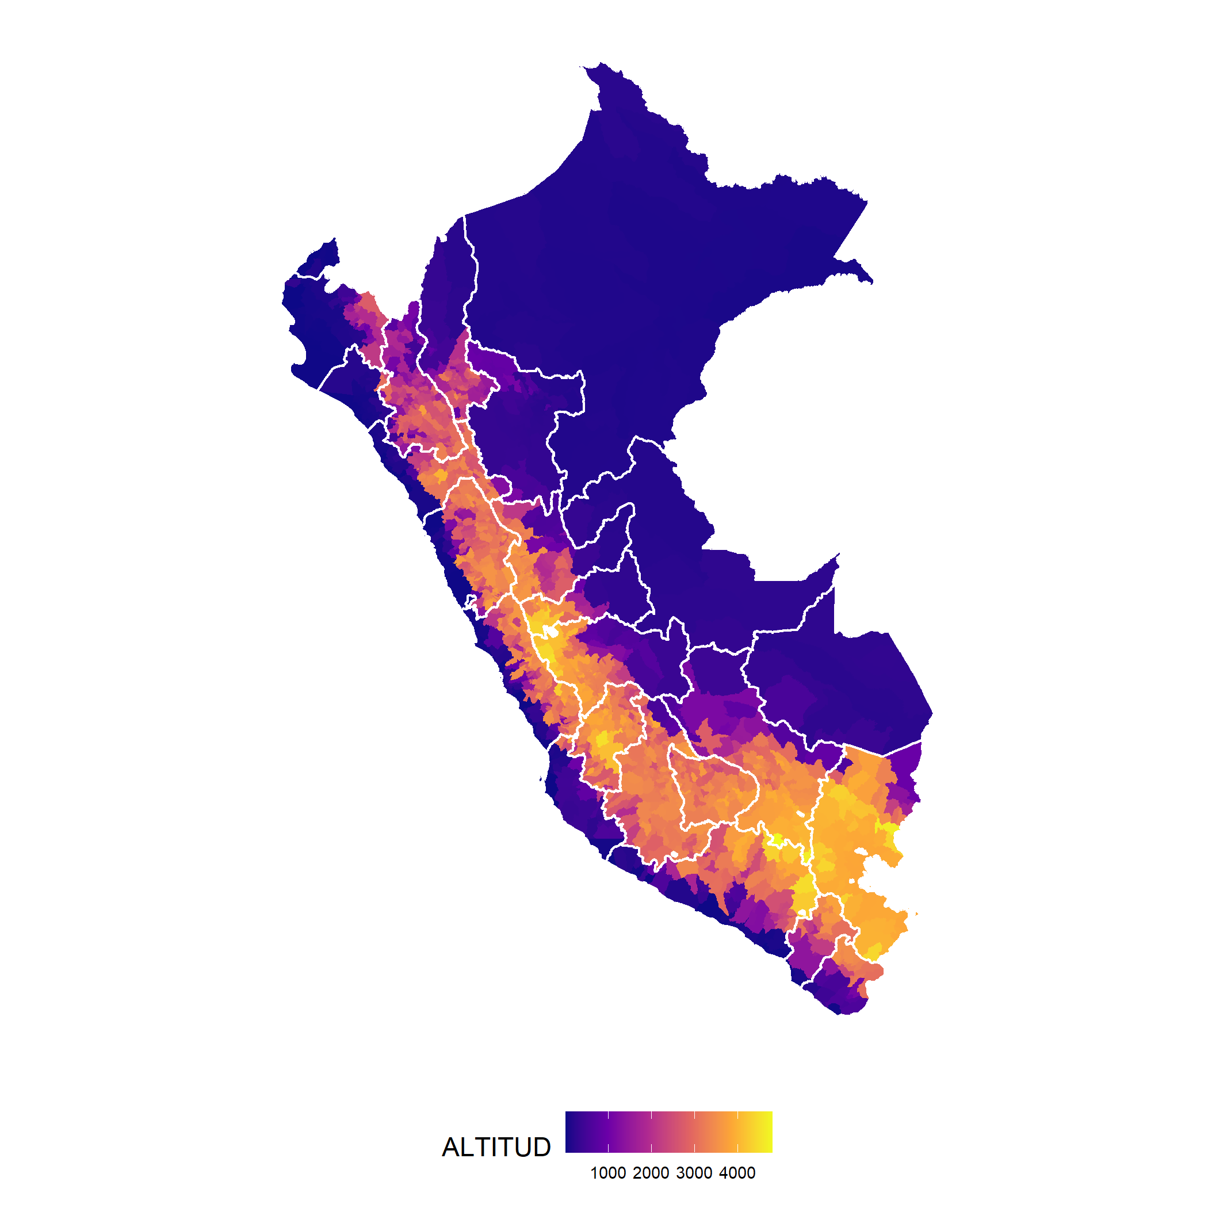

Figure 1: Administrative regions and altitude of Peru

## Figure 2

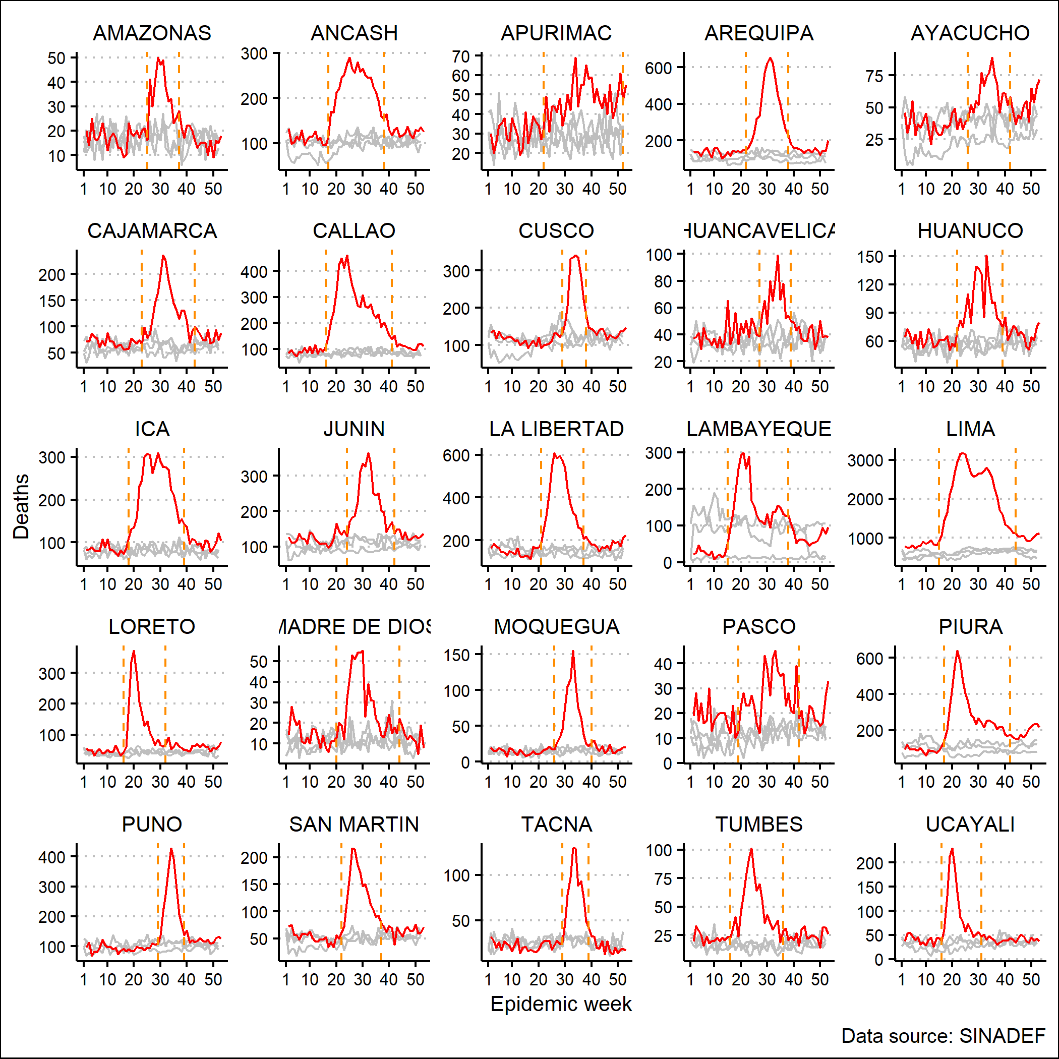

## Figure 3

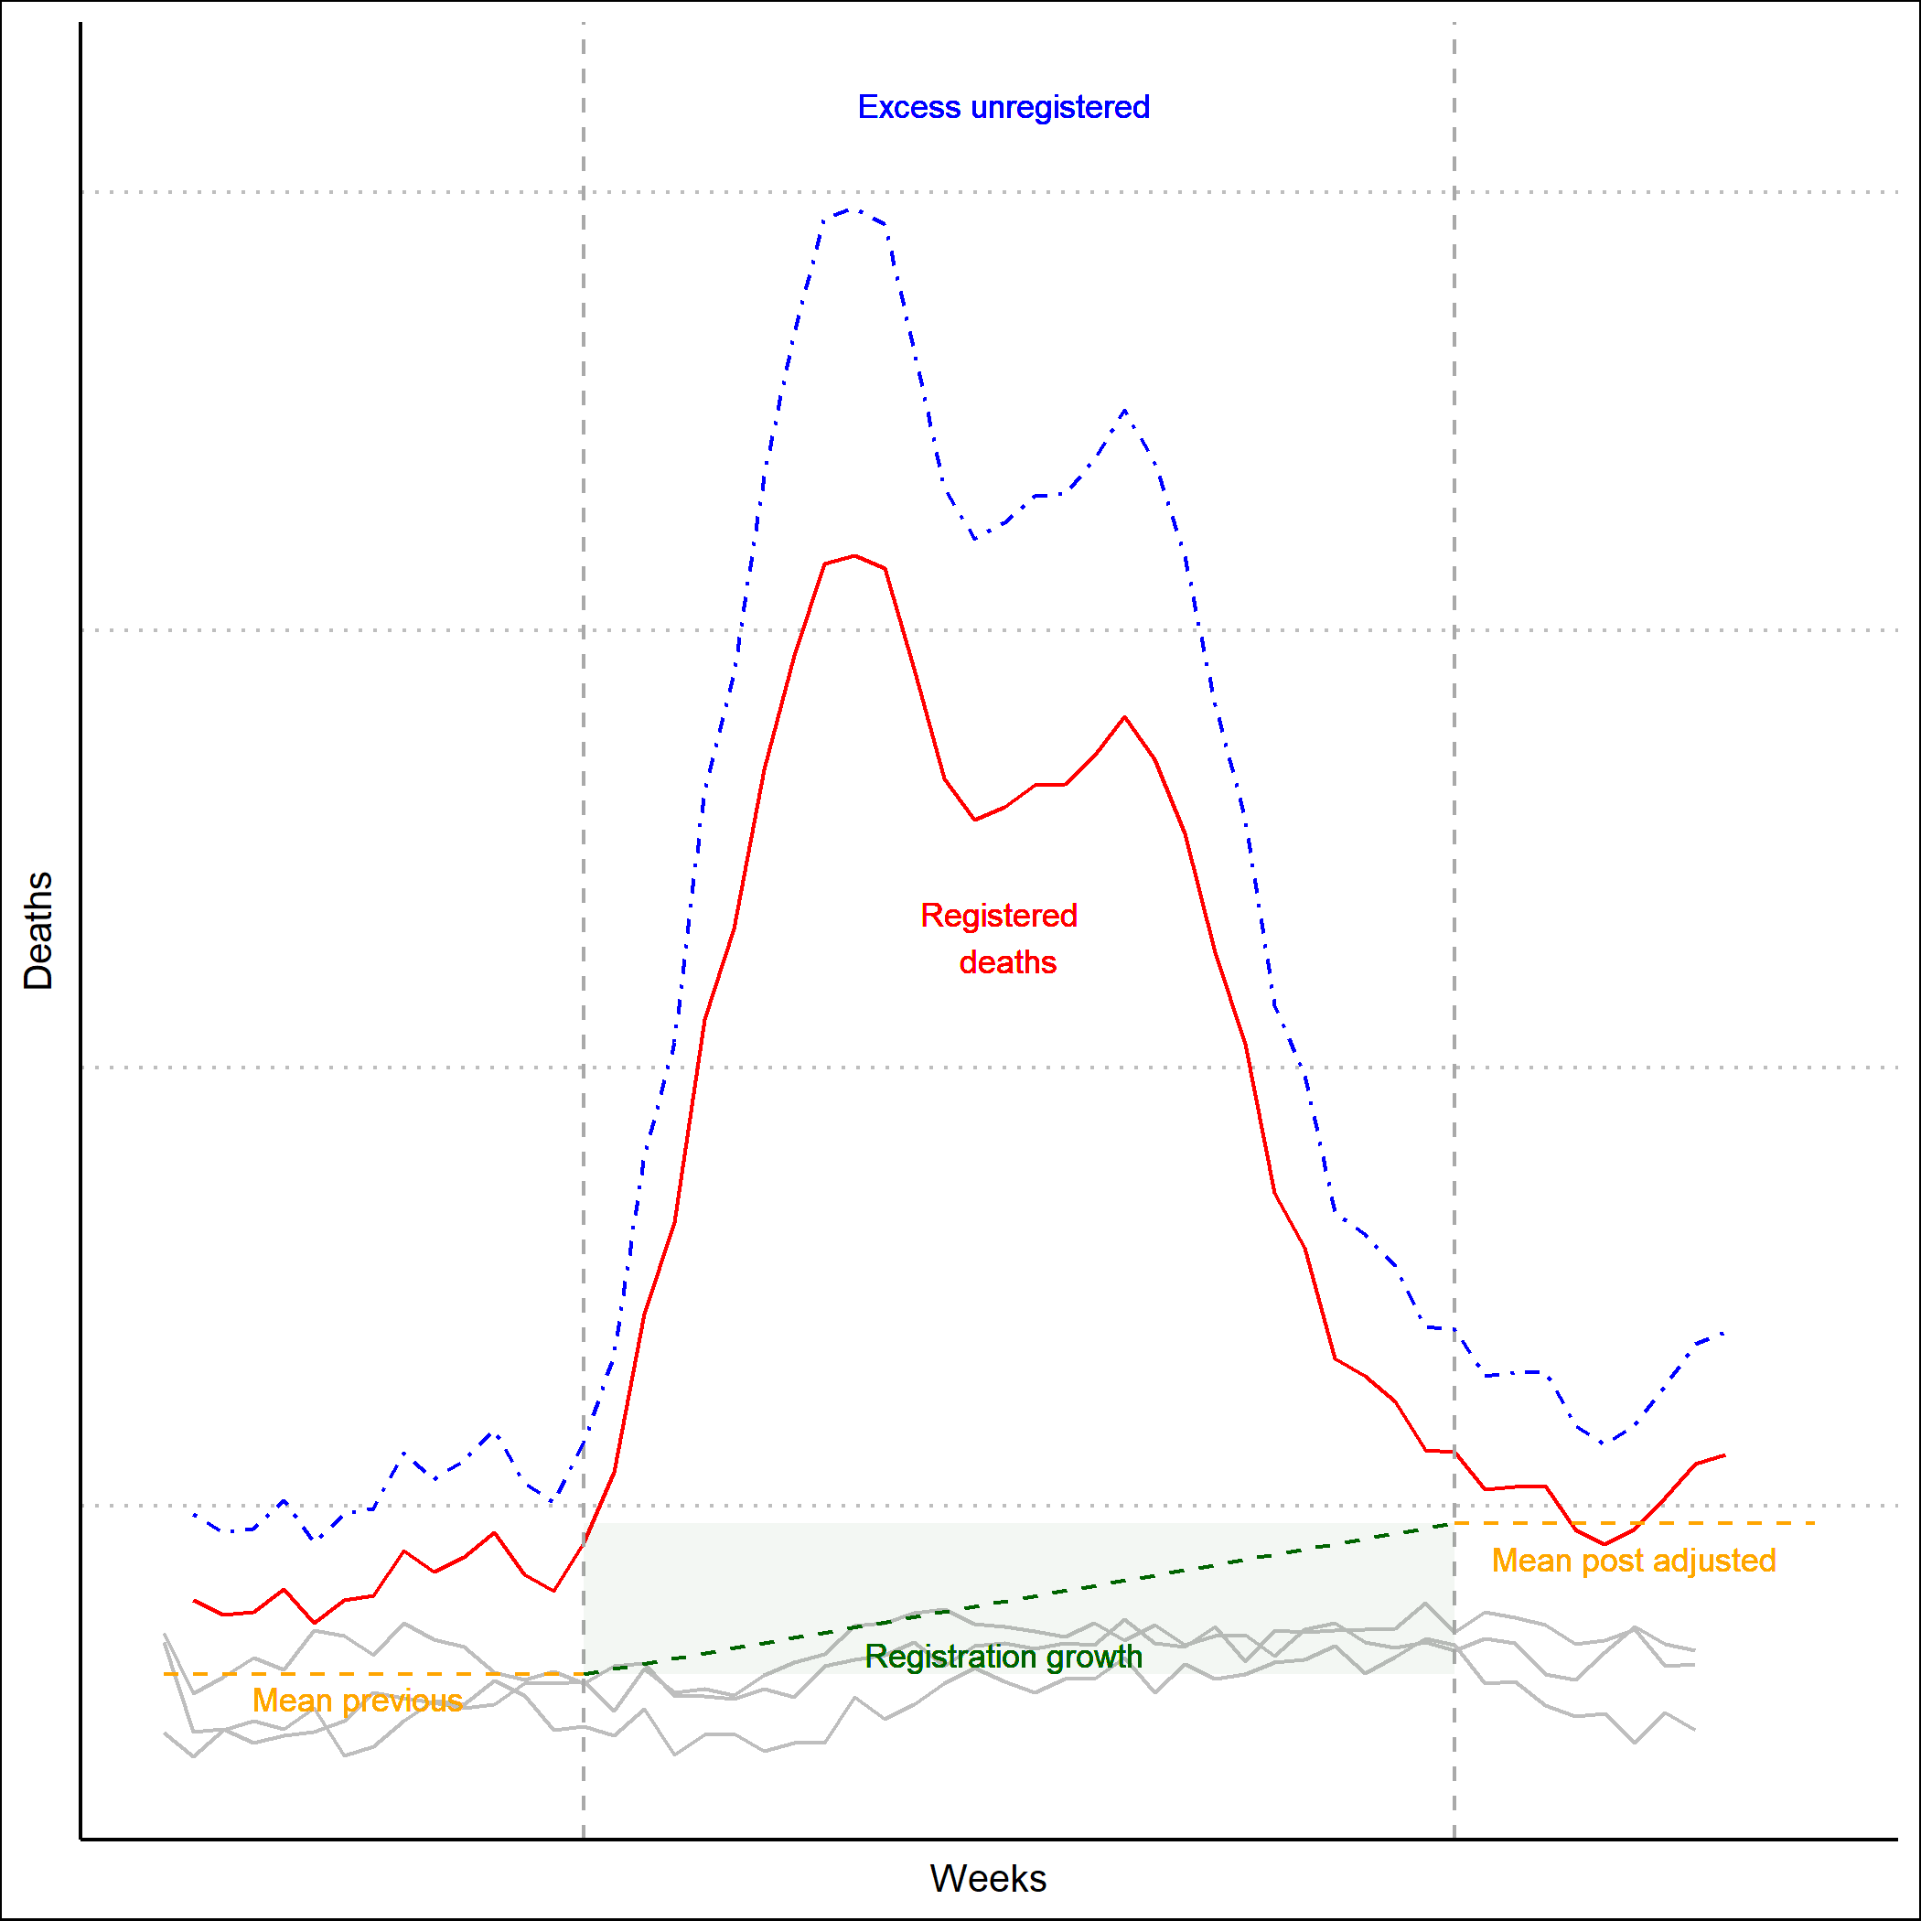

Figure 2: Conceptual representation of empirical strategy

## Figure 4



Figure 3: Flowchart: Data, analysis and outputs

## Figure 5

Figure 4: Weekly deaths during 2017-2020 by Region - Peru

## Figure 5

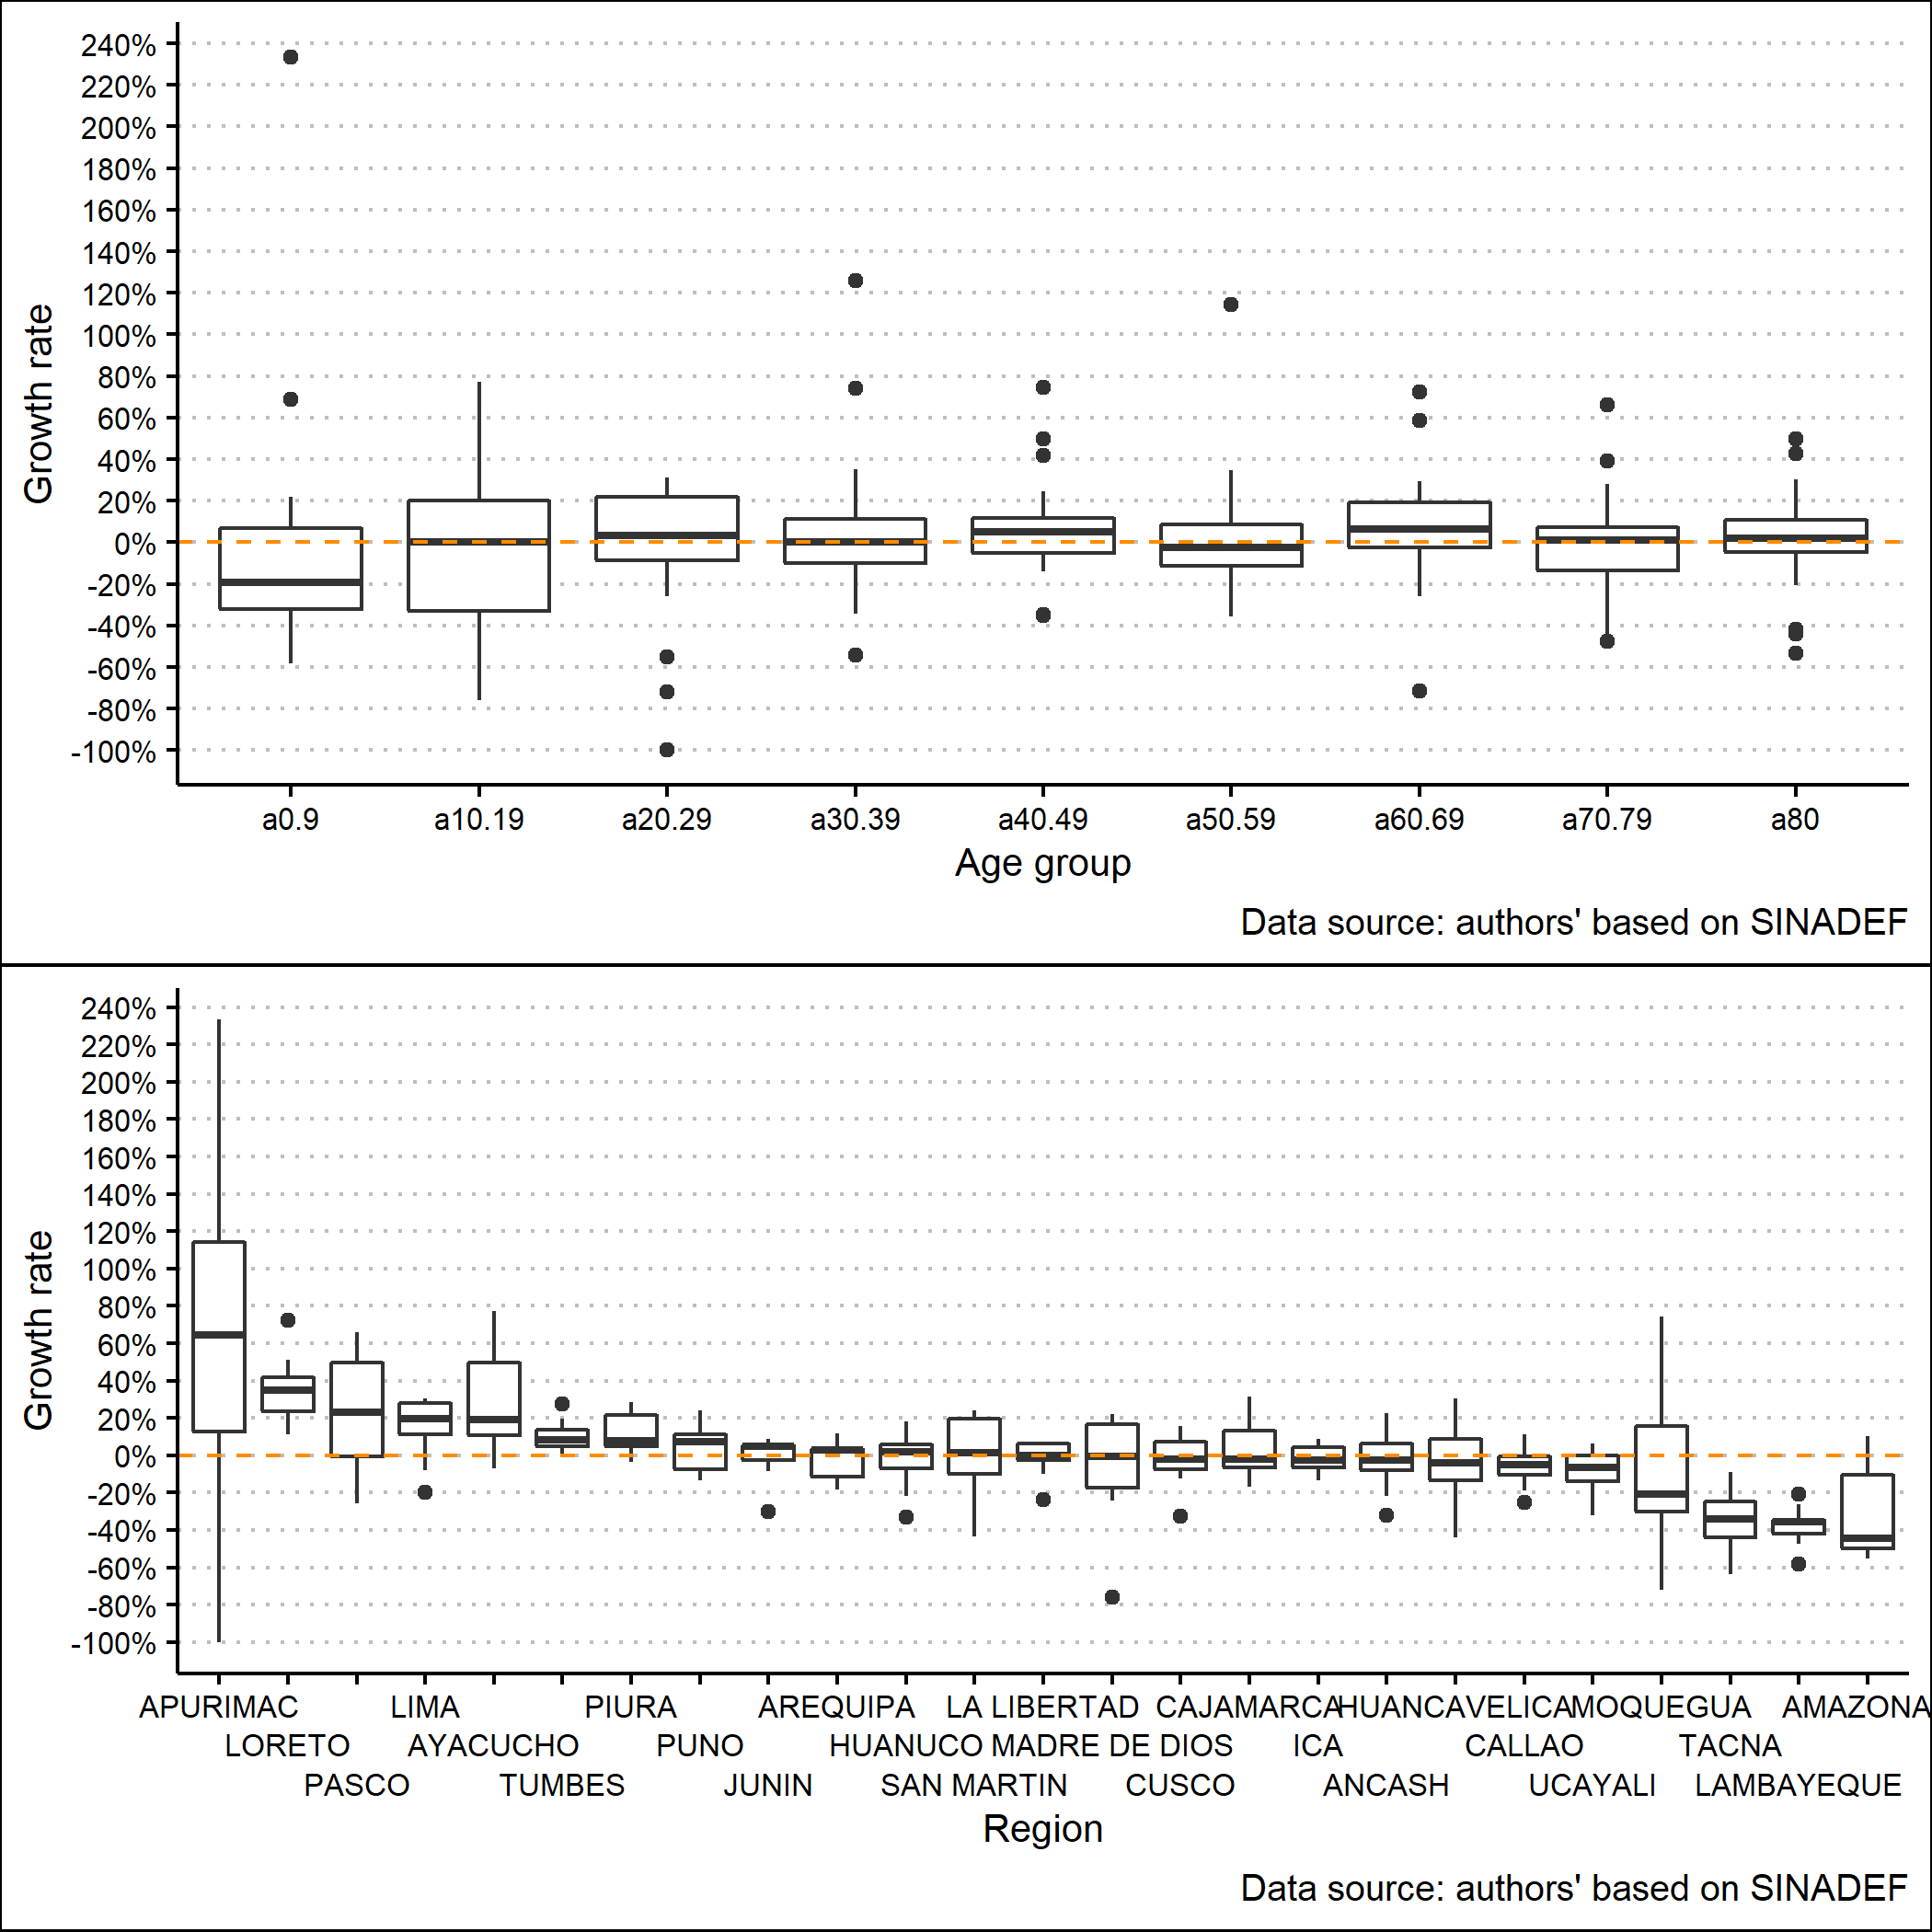

Figure 5: Estimated regional SINADEF growth rate by regions and age groups

## Figure 6

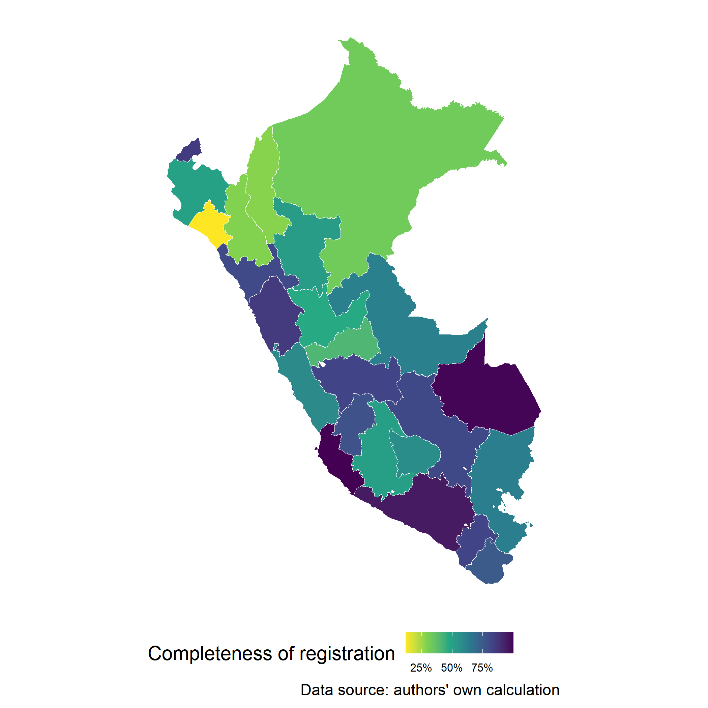

Figure 6: Estimation SINADEF completeness of registration before pandemics - Peru

## Figure 7

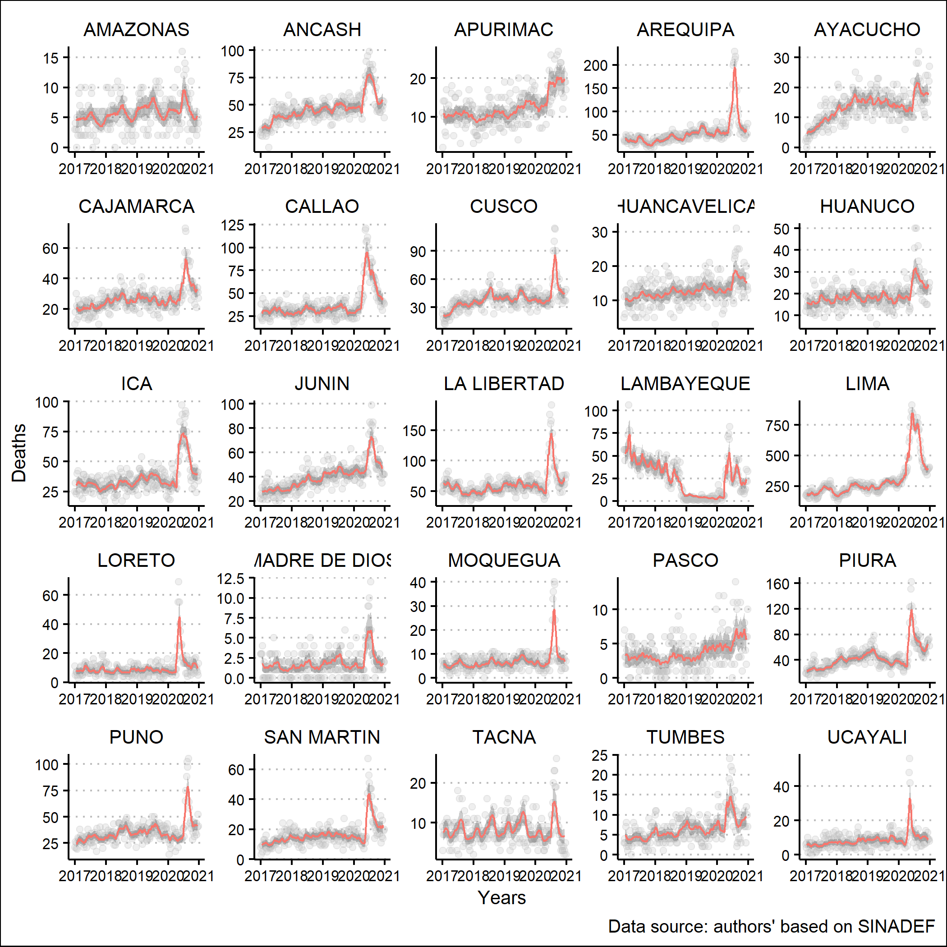

Figure 7: Predicted excess registered mortality by Region for age group over 80 - Peru

## Figure 8

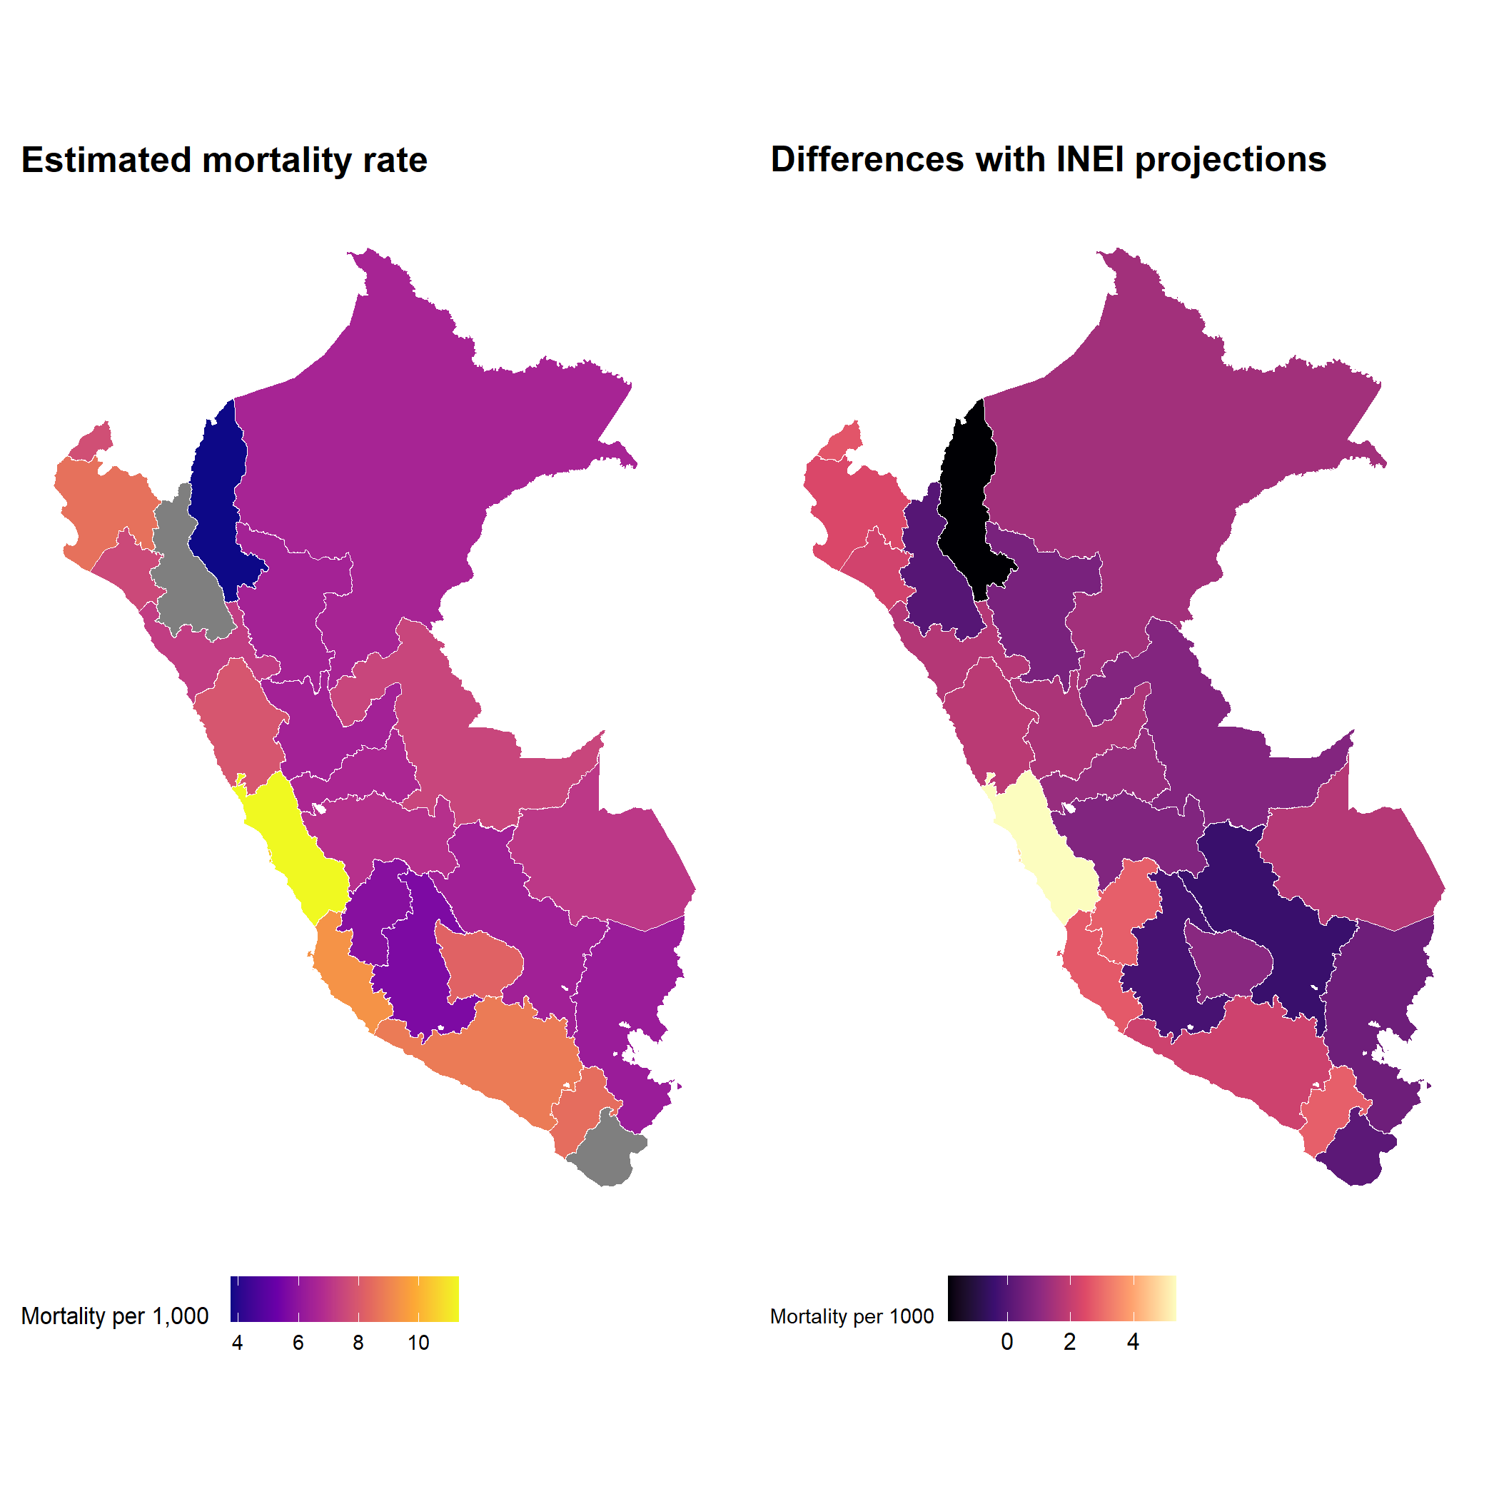

Figure 8: Estimated age-standardised mortality rates and differences with INEI projections

## Table 1

Table 1: Descriptive statistics - SINADEF & COVID-19 data

|  |  |  |  |
| --- | --- | --- | --- |
| Data | Observations | Age (sd) | % males |
| SINADEF 2017-2020 | 537054 | 66.35 (23.46) | 56 |
| COVID-19 | 36036 | 65.96 (14.66) | 68.8 |

## Table 2

Table 2: Summary of estimations, Peru, 2020.

|  |  |
| --- | --- |
| Terms | Estimates (95% CI) |
| COVID-19 deaths (MoH) | 1222 |
| Excess registered deaths | 108943 (96507 - 118261) |
| SINADEF registration growth | 1.5% |
| SINADEF under registration | 24.4% (14.6% - 40.5%) |
| Total excess mortality | 135557 (131826 - 160313) |
| Total estimated deaths in 2020 | 279951 (263194 - 322027) |

## Table 3

Table 3: Estimated total excess deaths by region

|  |  |  |
| --- | --- | --- |
| Region | Total excess | Excess registered |
| AMAZONAS | 377 (327 - 650) | 264 (170 - 314) |
| ANCASH | 3560 (3324 - 4643) | 3490 (2851 - 3999) |
| APURIMAC | 212 (180 - 265) | 62 (18 - 81) |
| AREQUIPA | 5326 (4856 - 6186) | 5273 (4564 - 5829) |
| AYACUCHO | 545 (422 - 910) | 353 (181 - 482) |
| CAJAMARCA | 2389 (2345 - 3640) | 1806 (1369 - 2129) |
| CALLAO | 7001 (6961 - 8104) | 6215 (5680 - 6617) |
| CUSCO | 1841 (1517 - 2730) | 1811 (1237 - 2253) |
| HUANCAVELICA | 263 (204 - 364) | 154 (77 - 207) |
| HUANUCO | 998 (617 - 2079) | 960 (440 - 1330) |
| ICA | 4246 (3691 - 4678) | 4226 (3659 - 4645) |
| JUNIN | 2552 (2182 - 3634) | 2526 (1823 - 3067) |
| LA LIBERTAD | 6979 (6870 - 8471) | 6502 (5742 - 7082) |
| LAMBAYEQUE | 8739 (8739 - 9278) | 4437 (4268 - 4531) |
| LIMA | 65283 (65215 - 73320) | 50925 (47738 - 53666) |
| LORETO | 3844 (3787 - 4610) | 2784 (2475 - 2984) |
| MADRE DE DIOS | 496 (320 - 607) | 492 (284 - 591) |
| MOQUEGUA | 912 (858 - 1170) | 889 (718 - 982) |
| PASCO | 314 (152 - 584) | 261 (68 - 363) |
| PIURA | 10750 (10704 - 12087) | 7733 (7196 - 8131) |
| PUNO | 2876 (2792 - 3963) | 2526 (2037 - 2891) |
| SAN MARTIN | 2185 (2164 - 3174) | 1870 (1447 - 2162) |
| TACNA | 800 (735 - 1146) | 755 (558 - 873) |
| TUMBES | 995 (871 - 1293) | 984 (753 - 1120) |
| UCAYALI | 2072 (1991 - 2728) | 1645 (1152 - 1932) |

## Table 4

Table 4: Estimated total excess deaths by age group

|  |  |  |
| --- | --- | --- |
| Age range | Total excess | Excess registered |
| < 10 | 180 (140 - 243) | -53 (-262 - 64) |
| 10-19 | 199 (134 - 267) | 91 (20 - 131) |
| 20-29 | 909 (682 - 1567) | 732 (354 - 980) |
| 30-39 | 3074 (2575 - 4507) | 2592 (1698 - 3151) |
| 40-49 | 10049 (9652 - 11812) | 8009 (6995 - 8693) |
| 50-59 | 20856 (20481 - 23912) | 16440 (14939 - 17493) |
| 60-69 | 33682 (33292 - 37870) | 26719 (24719 - 28200) |
| 70-79 | 34105 (33419 - 39694) | 27356 (24702 - 29402) |
| > 79 | 32502 (31450 - 40441) | 27057 (23341 - 30147) |

# Appendices

## Appendix 1

### Population 2020 per region

Table 5: Population 2020 per region

|  |  |
| --- | --- |
| Departamento | pop.INEI |
| MADRE DE DIOS | 153164 |
| MOQUEGUA | 189701 |
| TUMBES | 251363 |
| PASCO | 314677 |
| TACNA | 362331 |
| AMAZONAS | 427202 |
| APURIMAC | 467707 |
| HUANCAVELICA | 511794 |
| UCAYALI | 523086 |
| AYACUCHO | 725649 |
| ICA | 825042 |
| HUANUCO | 888845 |
| SAN MARTIN | 894564 |
| CALLAO | 1081491 |
| LORETO | 1085375 |
| ANCASH | 1177080 |
| LAMBAYEQUE | 1309731 |
| CUSCO | 1352476 |
| AREQUIPA | 1358108 |
| JUNIN | 1398361 |
| PUNO | 1485328 |
| CAJAMARCA | 1544325 |
| PIURA | 1914346 |
| LA LIBERTAD | 1973446 |
| LIMA | 10609166 |

### SINADEF registration growth

Table 6: SINADEF registration growth

|  |  |  |  |  |  |
| --- | --- | --- | --- | --- | --- |
| Departamento | range | se | mean.prev | mean.post | Change_registration |
| AMAZONAS | a0.9 | 0.9574 | 1.469 | 0.875 | -0.4043 |
| AMAZONAS | a10.19 | 0.5774 | 0.5 | 0.25 | -0.5 |
| AMAZONAS | a20.29 | 0.4787 | 0.6953 | 0.3125 | -0.5506 |
| AMAZONAS | a30.39 | 0.6292 | 0.9531 | 0.4375 | -0.541 |
| AMAZONAS | a40.49 | 0.8563 | 1.133 | 1.25 | 0.1034 |
| AMAZONAS | a50.59 | 1.204 | 1.539 | 1.375 | -0.1066 |
| AMAZONAS | a60.69 | 0.9106 | 1.828 | 1.812 | -0.008547 |
| AMAZONAS | a70.79 | 1.438 | 3.141 | 1.75 | -0.4428 |
| AMAZONAS | a80 | 2.024 | 5.938 | 3.312 | -0.4421 |
| ANCASH | a0.9 | 1.831 | 5.508 | 3.733 | -0.3222 |
| ANCASH | a10.19 | 1.187 | 2 | 1.867 | -0.06667 |
| ANCASH | a20.29 | 1.598 | 2.883 | 3.533 | 0.2254 |
| ANCASH | a30.39 | 1.207 | 3.575 | 2.8 | -0.2168 |
| ANCASH | a40.49 | 2.642 | 5.625 | 5.467 | -0.02815 |
| ANCASH | a50.59 | 3.555 | 8.708 | 9.267 | 0.06411 |
| ANCASH | a60.69 | 3.634 | 12.57 | 13.93 | 0.1088 |
| ANCASH | a70.79 | 4.682 | 21.56 | 22.73 | 0.0545 |
| ANCASH | a80 | 4.769 | 45.77 | 42.2 | -0.07793 |
| APURIMAC | a0.9 | NA | 1.8 | 6 | 2.333 |
| APURIMAC | a10.19 | NA | 0.608 | 1 | 0.6447 |
| APURIMAC | a20.29 | NA | 0.96 | 0 | -1 |
| APURIMAC | a30.39 | NA | 1.328 | 3 | 1.259 |
| APURIMAC | a40.49 | NA | 1.72 | 3 | 0.7442 |
| APURIMAC | a50.59 | NA | 2.8 | 6 | 1.143 |
| APURIMAC | a60.69 | NA | 3.48 | 1 | -0.7126 |
| APURIMAC | a70.79 | NA | 6.2 | 7 | 0.129 |
| APURIMAC | a80 | NA | 11.22 | 16 | 0.4255 |
| AREQUIPA | a0.9 | 2.404 | 4.984 | 4.067 | -0.1841 |
| AREQUIPA | a10.19 | 1.207 | 1.784 | 1.8 | 0.008969 |
| AREQUIPA | a20.29 | 1.345 | 4.2 | 4.333 | 0.03175 |
| AREQUIPA | a30.39 | 2.32 | 5.448 | 4.667 | -0.1434 |
| AREQUIPA | a40.49 | 3.321 | 6.992 | 7.8 | 0.1156 |
| AREQUIPA | a50.59 | 3.109 | 10.92 | 9.667 | -0.1148 |
| AREQUIPA | a60.69 | 3.751 | 15.46 | 16.73 | 0.08208 |
| AREQUIPA | a70.79 | 5.561 | 22.58 | 23.27 | 0.03023 |
| AREQUIPA | a80 | 7.539 | 49.9 | 51.47 | 0.03148 |
| AYACUCHO | a0.9 | 3.36 | 2.426 | 4.091 | 0.686 |
| AYACUCHO | a10.19 | 1.514 | 1.078 | 1.909 | 0.7717 |
| AYACUCHO | a20.29 | 1.578 | 1.767 | 2.091 | 0.183 |
| AYACUCHO | a30.39 | 1.679 | 1.682 | 2.273 | 0.3511 |
| AYACUCHO | a40.49 | 1.888 | 2.55 | 3.818 | 0.4971 |
| AYACUCHO | a50.59 | 1.737 | 3.264 | 3.273 | 0.002807 |
| AYACUCHO | a60.69 | 1.834 | 4.876 | 5.818 | 0.1932 |
| AYACUCHO | a70.79 | 3.749 | 7.899 | 7.364 | -0.0678 |
| AYACUCHO | a80 | 5.983 | 14.42 | 16 | 0.1097 |
| CAJAMARCA | a0.9 | 2.836 | 5.286 | 4.4 | -0.1676 |
| CAJAMARCA | a10.19 | NA | 1.214 | NA | NA |
| CAJAMARCA | a20.29 | 1.729 | 2.373 | 2.1 | -0.1151 |
| CAJAMARCA | a30.39 | 1.767 | 2.698 | 2.7 | 0.0005882 |
| CAJAMARCA | a40.49 | 2.119 | 3.635 | 4.4 | 0.2105 |
| CAJAMARCA | a50.59 | 2.514 | 5.405 | 7.1 | 0.3137 |
| CAJAMARCA | a60.69 | 2.573 | 7.397 | 8.2 | 0.1086 |
| CAJAMARCA | a70.79 | 3.665 | 12.72 | 12.1 | -0.04891 |
| CAJAMARCA | a80 | 5.808 | 25.98 | 24.8 | -0.04528 |
| CALLAO | a0.9 | 1.801 | 3.16 | 2.833 | -0.1033 |
| CALLAO | a10.19 | 1.206 | 1.235 | 1 | -0.1905 |
| CALLAO | a20.29 | 1.832 | 3.235 | 2.417 | -0.253 |
| CALLAO | a30.39 | 2.261 | 3.773 | 3.75 | -0.006125 |
| CALLAO | a40.49 | 2.498 | 4.924 | 4.667 | -0.05233 |
| CALLAO | a50.59 | 1.975 | 8.025 | 7.417 | -0.07583 |
| CALLAO | a60.69 | 5.728 | 12.86 | 12.58 | -0.0213 |
| CALLAO | a70.79 | 4.963 | 17.22 | 18.92 | 0.09863 |
| CALLAO | a80 | 5.23 | 31.34 | 34.92 | 0.1143 |
| CUSCO | a0.9 | 2.673 | 8.932 | 6 | -0.3282 |
| CUSCO | a10.19 | 1.397 | 3.227 | 3.667 | 0.1362 |
| CUSCO | a20.29 | 2.024 | 4.576 | 4.667 | 0.01987 |
| CUSCO | a30.39 | 2.588 | 5.068 | 5.867 | 0.1575 |
| CUSCO | a40.49 | 4.217 | 8.326 | 8.933 | 0.07298 |
| CUSCO | a50.59 | 2.356 | 11.98 | 10.47 | -0.1261 |
| CUSCO | a60.69 | 4.949 | 16.05 | 14.93 | -0.06975 |
| CUSCO | a70.79 | 4.301 | 24.56 | 22.73 | -0.0744 |
| CUSCO | a80 | 6.104 | 39.37 | 38.6 | -0.01959 |
| HUANCAVELICA | a0.9 | 1.139 | 3.062 | 1.714 | -0.4401 |
| HUANCAVELICA | a10.19 | 1.336 | 1.038 | 1.357 | 0.3069 |
| HUANCAVELICA | a20.29 | 1.277 | 1.362 | 1.643 | 0.2066 |
| HUANCAVELICA | a30.39 | 0.9376 | 1.438 | 1.429 | -0.006875 |
| HUANCAVELICA | a40.49 | 1.406 | 2.069 | 1.857 | -0.1025 |
| HUANCAVELICA | a50.59 | 1.167 | 3.308 | 2.857 | -0.1362 |
| HUANCAVELICA | a60.69 | 2.353 | 5.115 | 4 | -0.218 |
| HUANCAVELICA | a70.79 | 2.652 | 7.754 | 7.429 | -0.04195 |
| HUANCAVELICA | a80 | 3.401 | 12.65 | 13.79 | 0.08945 |
| HUANUCO | a0.9 | 1.881 | 4.488 | 3 | -0.3316 |
| HUANUCO | a10.19 | 1.216 | 1.416 | 1.357 | -0.04157 |
| HUANUCO | a20.29 | 1.646 | 2.536 | 2.357 | -0.07053 |
| HUANUCO | a30.39 | 2.016 | 2.776 | 3.286 | 0.1836 |
| HUANUCO | a40.49 | 2.598 | 3.936 | 4.143 | 0.05256 |
| HUANUCO | a50.59 | 2.277 | 5.68 | 4.429 | -0.2203 |
| HUANUCO | a60.69 | 2.895 | 7.368 | 7.929 | 0.07608 |
| HUANUCO | a70.79 | 2.84 | 11.63 | 12.29 | 0.0562 |
| HUANUCO | a80 | 3.775 | 18.03 | 18.36 | 0.01803 |
| ICA | a0.9 | 1.158 | 3.736 | 3.571 | -0.04393 |
| ICA | a10.19 | 1.269 | 1.198 | 1.071 | -0.1059 |
| ICA | a20.29 | 1.9 | 2.694 | 2.929 | 0.08699 |
| ICA | a30.39 | 2.316 | 3.223 | 3.143 | -0.02491 |
| ICA | a40.49 | 2.742 | 4.868 | 4.857 | -0.002183 |
| ICA | a50.59 | 2.615 | 7.298 | 7.929 | 0.08647 |
| ICA | a60.69 | 4.237 | 10.96 | 11.43 | 0.04288 |
| ICA | a70.79 | 5.912 | 16.43 | 14.21 | -0.1348 |
| ICA | a80 | 5.717 | 32.93 | 30.71 | -0.06716 |
| JUNIN | a0.9 | 3.202 | 7.268 | 7.636 | 0.05072 |
| JUNIN | a10.19 | 1.342 | 2.858 | 2 | -0.3003 |
| JUNIN | a20.29 | 2.089 | 4.165 | 3.818 | -0.08335 |
| JUNIN | a30.39 | 2.339 | 5.094 | 5.455 | 0.07068 |
| JUNIN | a40.49 | 3.012 | 6.945 | 7.545 | 0.08648 |
| JUNIN | a50.59 | 3.015 | 10.39 | 10.91 | 0.04959 |
| JUNIN | a60.69 | 4.384 | 15.13 | 14.73 | -0.02636 |
| JUNIN | a70.79 | 5.605 | 23.05 | 24.27 | 0.05317 |
| JUNIN | a80 | 8.287 | 40.69 | 41.55 | 0.02095 |
| LA LIBERTAD | a0.9 | 3.011 | 7.895 | 6 | -0.24 |
| LA LIBERTAD | a10.19 | 1.844 | 2.758 | 2.75 | -0.002924 |
| LA LIBERTAD | a20.29 | 1.815 | 5.323 | 5.688 | 0.06856 |
| LA LIBERTAD | a30.39 | 2.562 | 6.331 | 6.188 | -0.02261 |
| LA LIBERTAD | a40.49 | 3.75 | 8.484 | 9.062 | 0.0682 |
| LA LIBERTAD | a50.59 | 3.512 | 13.6 | 12.25 | -0.09959 |
| LA LIBERTAD | a60.69 | 5.899 | 20.22 | 21.5 | 0.06342 |
| LA LIBERTAD | a70.79 | 6.946 | 30.72 | 32.62 | 0.06209 |
| LA LIBERTAD | a80 | 9.228 | 56.15 | 54.69 | -0.0261 |
| LAMBAYEQUE | a0.9 | 1.207 | 2.881 | 1.2 | -0.5835 |
| LAMBAYEQUE | a10.19 | 1.06 | 0.7966 | 0.4667 | -0.4142 |
| LAMBAYEQUE | a20.29 | 1.246 | 1.534 | 1.133 | -0.2611 |
| LAMBAYEQUE | a30.39 | 0.6761 | 1.831 | 1.2 | -0.3444 |
| LAMBAYEQUE | a40.49 | 1.751 | 2.661 | 1.733 | -0.3486 |
| LAMBAYEQUE | a50.59 | 1.727 | 3.924 | 2.533 | -0.3544 |
| LAMBAYEQUE | a60.69 | 3.619 | 5.907 | 4.667 | -0.2099 |
| LAMBAYEQUE | a70.79 | 3.411 | 8.127 | 4.267 | -0.475 |
| LAMBAYEQUE | a80 | 8.147 | 14.91 | 8.667 | -0.4186 |
| LIMA | a0.9 | 5.578 | 30.08 | 24.11 | -0.1986 |
| LIMA | a10.19 | 3.127 | 7.992 | 9.556 | 0.1957 |
| LIMA | a20.29 | 5.916 | 19.92 | 18.33 | -0.07943 |
| LIMA | a30.39 | 6.187 | 27.5 | 30.56 | 0.1111 |
| LIMA | a40.49 | 9.179 | 39.14 | 48.67 | 0.2435 |
| LIMA | a50.59 | 13.26 | 63.02 | 73.44 | 0.1655 |
| LIMA | a60.69 | 16.74 | 98.2 | 127.1 | 0.2944 |
| LIMA | a70.79 | 12.43 | 136.3 | 174.3 | 0.2792 |
| LIMA | a80 | 20.82 | 251.1 | 327.1 | 0.3029 |
| LORETO | a0.9 | 2.408 | 5.361 | 6 | 0.1191 |
| LORETO | a10.19 | 1.153 | 1.227 | 1.857 | 0.5137 |
| LORETO | a20.29 | 1.411 | 2.437 | 3.095 | 0.2701 |
| LORETO | a30.39 | 2.089 | 3.168 | 3.524 | 0.1123 |
| LORETO | a40.49 | 2.448 | 3.689 | 5.238 | 0.4199 |
| LORETO | a50.59 | 3.006 | 4.941 | 6.667 | 0.3492 |
| LORETO | a60.69 | 3.82 | 5.664 | 9.762 | 0.7235 |
| LORETO | a70.79 | 3.246 | 6.697 | 9.333 | 0.3936 |
| LORETO | a80 | 3.84 | 7.782 | 9.619 | 0.2361 |
| MADRE DE DIOS | a0.9 | 1.236 | 1.276 | 1.556 | 0.2187 |
| MADRE DE DIOS | a10.19 | 0.3333 | 0.4634 | 0.1111 | -0.7602 |
| MADRE DE DIOS | a20.29 | 1.509 | 1.187 | 1.444 | 0.2169 |
| MADRE DE DIOS | a30.39 | 0.866 | 1.171 | 1.333 | 0.1389 |
| MADRE DE DIOS | a40.49 | 1.424 | 1.333 | 1.556 | 0.1667 |
| MADRE DE DIOS | a50.59 | 1 | 1.545 | 1.333 | -0.1368 |
| MADRE DE DIOS | a60.69 | 1 | 1.756 | 1.333 | -0.2407 |
| MADRE DE DIOS | a70.79 | 1.414 | 1.61 | 1.333 | -0.1717 |
| MADRE DE DIOS | a80 | 0.7071 | 1.675 | 1.667 | -0.004854 |
| MOQUEGUA | a0.9 | 0.6504 | 0.5504 | 0.3846 | -0.3012 |
| MOQUEGUA | a10.19 | 0.2774 | 0.2481 | 0.07692 | -0.6899 |
| MOQUEGUA | a20.29 | 0.3755 | 0.5504 | 0.1538 | -0.7205 |
| MOQUEGUA | a30.39 | 0.9268 | 0.4419 | 0.7692 | 0.7409 |
| MOQUEGUA | a40.49 | 1.166 | 0.8605 | 0.7692 | -0.106 |
| MOQUEGUA | a50.59 | 1.363 | 1.395 | 1.769 | 0.2679 |
| MOQUEGUA | a60.69 | 2.367 | 2.132 | 2.462 | 0.1547 |
| MOQUEGUA | a70.79 | 1.758 | 3.062 | 2.385 | -0.2212 |
| MOQUEGUA | a80 | 1.891 | 6.403 | 5.077 | -0.2071 |
| PASCO | a0.9 | 1.044 | 1.221 | 0.9091 | -0.2556 |
| PASCO | a10.19 | 0.5045 | 0.2951 | 0.3636 | 0.2323 |
| PASCO | a20.29 | 0.9816 | 0.623 | 0.8182 | 0.3134 |
| PASCO | a30.39 | 0.9816 | 0.7377 | 0.8182 | 0.1091 |
| PASCO | a40.49 | 1.342 | 1.016 | 1 | -0.01613 |
| PASCO | a50.59 | 1.191 | 1.279 | 1.273 | -0.004662 |
| PASCO | a60.69 | 1.286 | 1.664 | 2.636 | 0.5844 |
| PASCO | a70.79 | 1.673 | 2.41 | 4 | 0.6599 |
| PASCO | a80 | 2.49 | 3.336 | 5 | 0.4988 |
| PIURA | a0.9 | 3.295 | 6.5 | 7.636 | 0.1748 |
| PIURA | a10.19 | 1.804 | 1.942 | 2.364 | 0.2173 |
| PIURA | a20.29 | 1.578 | 3.817 | 4.909 | 0.2862 |
| PIURA | a30.39 | 2.335 | 4.275 | 4.364 | 0.02073 |
| PIURA | a40.49 | 2.449 | 6.5 | 7 | 0.07692 |
| PIURA | a50.59 | 2.757 | 11.42 | 11 | -0.0365 |
| PIURA | a60.69 | 4.692 | 16.67 | 20.27 | 0.2164 |
| PIURA | a70.79 | 4.777 | 21.98 | 23.73 | 0.07933 |
| PIURA | a80 | 5.437 | 41.81 | 43.82 | 0.04807 |
| PUNO | a0.9 | 2 | 7.576 | 7 | -0.076 |
| PUNO | a10.19 | 2.134 | 2.371 | 2.643 | 0.1146 |
| PUNO | a20.29 | 2.723 | 4.348 | 5.214 | 0.1991 |
| PUNO | a30.39 | 2.977 | 5.023 | 4.357 | -0.1325 |
| PUNO | a40.49 | 3.204 | 7.061 | 6.429 | -0.08952 |
| PUNO | a50.59 | 2.463 | 9.894 | 9.286 | -0.06147 |
| PUNO | a60.69 | 3.407 | 13.14 | 16.29 | 0.2397 |
| PUNO | a70.79 | 3.995 | 21.08 | 22.57 | 0.07097 |
| PUNO | a80 | 5.932 | 34.42 | 37.5 | 0.08959 |
| SAN MARTIN | a0.9 | 1.39 | 4.352 | 3.25 | -0.2532 |
| SAN MARTIN | a10.19 | 0.9574 | 1.544 | 0.875 | -0.4333 |
| SAN MARTIN | a20.29 | 1.914 | 2.368 | 2.938 | 0.2405 |
| SAN MARTIN | a30.39 | 1.448 | 2.984 | 2.688 | -0.09936 |
| SAN MARTIN | a40.49 | 1.983 | 4.256 | 4.25 | -0.00141 |
| SAN MARTIN | a50.59 | 2.206 | 5.816 | 6.25 | 0.07462 |
| SAN MARTIN | a60.69 | 3.124 | 7.416 | 9.188 | 0.2389 |
| SAN MARTIN | a70.79 | 2.536 | 9.696 | 9.812 | 0.01202 |
| SAN MARTIN | a80 | 4.875 | 14.86 | 17.81 | 0.1984 |
| TACNA | a0.9 | NA | 1.068 | NA | NA |
| TACNA | a10.19 | 0.5345 | 0.3939 | 0.1429 | -0.6374 |
| TACNA | a20.29 | 0.8644 | 0.9394 | 0.8571 | -0.08756 |
| TACNA | a30.39 | 0.5547 | 1.28 | 1 | -0.2189 |
| TACNA | a40.49 | 0.9493 | 1.765 | 1.143 | -0.3525 |
| TACNA | a50.59 | 1.73 | 2.886 | 1.929 | -0.3318 |
| TACNA | a60.69 | 2.235 | 4.136 | 3.071 | -0.2575 |
| TACNA | a70.79 | 1.492 | 5.174 | 3.071 | -0.4064 |
| TACNA | a80 | 1.718 | 8.091 | 3.786 | -0.5321 |
| TUMBES | a0.9 | 1.111 | 0.9832 | 1.118 | 0.1368 |
| TUMBES | a10.19 | 0.7123 | 0.3445 | 0.4118 | 0.1951 |
| TUMBES | a20.29 | 0.8993 | 0.7395 | 0.9412 | 0.2727 |
| TUMBES | a30.39 | 0.7906 | 0.9244 | 1 | 0.08182 |
| TUMBES | a40.49 | 0.9196 | 1.235 | 1.294 | 0.04762 |
| TUMBES | a50.59 | 1.522 | 1.983 | 2.235 | 0.1271 |
| TUMBES | a60.69 | 1.576 | 3.076 | 3.118 | 0.01366 |
| TUMBES | a70.79 | 1.419 | 3.504 | 3.529 | 0.007194 |
| TUMBES | a80 | 2.623 | 6.118 | 6.412 | 0.04808 |
| UCAYALI | a0.9 | 1.497 | 3.471 | 2.364 | -0.319 |
| UCAYALI | a10.19 | 1.133 | 0.9832 | 1.045 | 0.06333 |
| UCAYALI | a20.29 | 1.327 | 2.193 | 2.045 | -0.0674 |
| UCAYALI | a30.39 | 1.62 | 2.605 | 2.364 | -0.09267 |
| UCAYALI | a40.49 | 1.427 | 3.118 | 2.682 | -0.1398 |
| UCAYALI | a50.59 | 2.381 | 4.471 | 4.364 | -0.02392 |
| UCAYALI | a60.69 | 3.139 | 5.807 | 6.045 | 0.04111 |
| UCAYALI | a70.79 | 2.937 | 6.361 | 5.364 | -0.1568 |
| UCAYALI | a80 | 2.645 | 8.067 | 8.045 | -0.002699 |

### Model fit registration completeness

Table 7: Model fit Mixed-effect logistic regression

|  |  |  |  |
| --- | --- | --- | --- |
| R2m | R2c | RMSE.normalised | RMSE |
| 0.7437 | 0.8699 | 0.05268 | 0.239 |

### Under-registration rates

Table 8: Under-registration rates

|  |  |
| --- | --- |
| Departamento | sub.mean |
| ICA | 99.85 |
| MADRE DE DIOS | 99.18 |
| AREQUIPA | 94.78 |
| ANCASH | 85.12 |
| TUMBES | 85.03 |
| JUNIN | 82.28 |
| MOQUEGUA | 82.14 |
| CUSCO | 80.78 |
| LA LIBERTAD | 80.41 |
| HUANCAVELICA | 77.72 |
| CALLAO | 77.51 |
| TACNA | 74.43 |
| PUNO | 62.26 |
| UCAYALI | 61.83 |
| LIMA | 58.07 |
| APURIMAC | 57 |
| SAN MARTIN | 51.55 |
| AYACUCHO | 50.54 |
| PIURA | 49.46 |
| HUANUCO | 46.56 |
| PASCO | 40.59 |
| LORETO | 32.12 |
| CAJAMARCA | 28.45 |
| AMAZONAS | 28.01 |
| LAMBAYEQUE | 11.87 |

### Quasi-Poisson models

Table 6: Model fit Quasi-Poisson

|  |  |  |  |  |  |  |  |  |  |  |  |  |  |
| --- | --- | --- | --- | --- | --- | --- | --- | --- | --- | --- | --- | --- | --- |
| Departamento | range | null.deviance | df.null | logLik | AIC | BIC | deviance | df.residual | nobs | fit | dif.dev | df | p |
| AMAZONAS | a0.9 | 275.7 | 206 | NA | NA | NA | 213.5 | 189 | 207 | 0.2254 | 62.12 | 17 | 4.674e-07 |
| AMAZONAS | a10.19 | 223 | 206 | NA | NA | NA | 204.7 | 189 | 207 | 0.08207 | 18.3 | 17 | 0.3703 |
| AMAZONAS | a20.29 | 207.7 | 206 | NA | NA | NA | 191.4 | 189 | 207 | 0.07888 | 16.39 | 17 | 0.4966 |
| AMAZONAS | a30.39 | 242.3 | 206 | NA | NA | NA | 210.1 | 189 | 207 | 0.1328 | 32.17 | 17 | 0.01433 |
| AMAZONAS | a40.49 | 232.5 | 206 | NA | NA | NA | 205.8 | 189 | 207 | 0.1147 | 26.66 | 17 | 0.0633 |
| AMAZONAS | a50.59 | 260.6 | 206 | NA | NA | NA | 210.1 | 189 | 207 | 0.1938 | 50.5 | 17 | 0.00003528 |
| AMAZONAS | a60.69 | 392.6 | 206 | NA | NA | NA | 252 | 189 | 207 | 0.358 | 140.5 | 17 | 1.729e-21 |
| AMAZONAS | a70.79 | 285.3 | 206 | NA | NA | NA | 231.6 | 189 | 207 | 0.1882 | 53.69 | 17 | 0.00001109 |
| AMAZONAS | a80 | 291.1 | 206 | NA | NA | NA | 234.2 | 189 | 207 | 0.1955 | 56.92 | 17 | 3.36e-06 |
| ANCASH | a0.9 | 240.9 | 206 | NA | NA | NA | 202 | 189 | 207 | 0.1615 | 38.9 | 17 | 0.001846 |
| ANCASH | a10.19 | 225.8 | 206 | NA | NA | NA | 214.3 | 189 | 207 | 0.05078 | 11.47 | 17 | 0.8313 |
| ANCASH | a20.29 | 219.5 | 206 | NA | NA | NA | 203.8 | 189 | 207 | 0.07114 | 15.61 | 17 | 0.5514 |
| ANCASH | a30.39 | 235.8 | 206 | NA | NA | NA | 201.3 | 189 | 207 | 0.1462 | 34.49 | 17 | 0.007252 |
| ANCASH | a40.49 | 370.5 | 206 | NA | NA | NA | 222.8 | 189 | 207 | 0.3986 | 147.7 | 17 | 7.004e-23 |
| ANCASH | a50.59 | 769.7 | 206 | NA | NA | NA | 244.3 | 189 | 207 | 0.6826 | 525.4 | 17 | 8.43e-101 |
| ANCASH | a60.69 | 1102 | 206 | NA | NA | NA | 248.7 | 189 | 207 | 0.7744 | 853.8 | 17 | 1.537e-170 |
| ANCASH | a70.79 | 1083 | 206 | NA | NA | NA | 266.8 | 189 | 207 | 0.7538 | 816.6 | 17 | 1.346e-162 |
| ANCASH | a80 | 749.1 | 206 | NA | NA | NA | 251.2 | 189 | 207 | 0.6647 | 498 | 17 | 5.11e-95 |
| APURIMAC | a0.9 | 241.7 | 206 | NA | NA | NA | 227.8 | 189 | 207 | 0.05727 | 13.84 | 17 | 0.6783 |
| APURIMAC | a10.19 | 211.6 | 206 | NA | NA | NA | 187.5 | 189 | 207 | 0.1142 | 24.17 | 17 | 0.115 |
| APURIMAC | a20.29 | 247.1 | 206 | NA | NA | NA | 228.1 | 189 | 207 | 0.07703 | 19.03 | 17 | 0.3266 |
| APURIMAC | a30.39 | 251 | 206 | NA | NA | NA | 221.6 | 189 | 207 | 0.1172 | 29.42 | 17 | 0.03085 |
| APURIMAC | a40.49 | 285.6 | 206 | NA | NA | NA | 258.9 | 189 | 207 | 0.09351 | 26.71 | 17 | 0.06251 |
| APURIMAC | a50.59 | 282.8 | 206 | NA | NA | NA | 228.1 | 189 | 207 | 0.1936 | 54.77 | 17 | 7.473e-06 |
| APURIMAC | a60.69 | 343.1 | 206 | NA | NA | NA | 262.2 | 189 | 207 | 0.2357 | 80.86 | 17 | 2.699e-10 |
| APURIMAC | a70.79 | 263.9 | 206 | NA | NA | NA | 195.2 | 189 | 207 | 0.2602 | 68.65 | 17 | 3.671e-08 |
| APURIMAC | a80 | 372.2 | 206 | NA | NA | NA | 212.3 | 189 | 207 | 0.4295 | 159.8 | 17 | 2.847e-25 |
| AREQUIPA | a0.9 | 280.9 | 206 | NA | NA | NA | 252.8 | 189 | 207 | 0.1 | 28.09 | 17 | 0.04391 |
| AREQUIPA | a10.19 | 256.9 | 206 | NA | NA | NA | 238.2 | 189 | 207 | 0.07301 | 18.76 | 17 | 0.3426 |
| AREQUIPA | a20.29 | 229.9 | 206 | NA | NA | NA | 200.2 | 189 | 207 | 0.1293 | 29.74 | 17 | 0.02828 |
| AREQUIPA | a30.39 | 278.8 | 206 | NA | NA | NA | 214.6 | 189 | 207 | 0.2303 | 64.18 | 17 | 2.109e-07 |
| AREQUIPA | a40.49 | 632.9 | 206 | NA | NA | NA | 274.2 | 189 | 207 | 0.5668 | 358.8 | 17 | 7.38e-66 |
| AREQUIPA | a50.59 | 1486 | 206 | NA | NA | NA | 325.1 | 189 | 207 | 0.7813 | 1161 | 17 | 2.992e-236 |
| AREQUIPA | a60.69 | 2421 | 206 | NA | NA | NA | 346.4 | 189 | 207 | 0.8569 | 2075 | 17 | 0 |
| AREQUIPA | a70.79 | 2436 | 206 | NA | NA | NA | 334.8 | 189 | 207 | 0.8625 | 2101 | 17 | 0 |
| AREQUIPA | a80 | 2587 | 206 | NA | NA | NA | 321.3 | 189 | 207 | 0.8758 | 2266 | 17 | 0 |
| AYACUCHO | a0.9 | 337.6 | 206 | NA | NA | NA | 261.5 | 189 | 207 | 0.2254 | 76.1 | 17 | 1.874e-09 |
| AYACUCHO | a10.19 | 257 | 206 | NA | NA | NA | 225.8 | 189 | 207 | 0.1215 | 31.22 | 17 | 0.01877 |
| AYACUCHO | a20.29 | 233.3 | 206 | NA | NA | NA | 193.6 | 189 | 207 | 0.17 | 39.64 | 17 | 0.001453 |
| AYACUCHO | a30.39 | 262 | 206 | NA | NA | NA | 215.1 | 189 | 207 | 0.179 | 46.89 | 17 | 0.0001266 |
| AYACUCHO | a40.49 | 329.3 | 206 | NA | NA | NA | 259.6 | 189 | 207 | 0.2114 | 69.62 | 17 | 2.51e-08 |
| AYACUCHO | a50.59 | 316.9 | 206 | NA | NA | NA | 231.7 | 189 | 207 | 0.269 | 85.23 | 17 | 4.447e-11 |
| AYACUCHO | a60.69 | 374.8 | 206 | NA | NA | NA | 208 | 189 | 207 | 0.4451 | 166.8 | 17 | 1.199e-26 |
| AYACUCHO | a70.79 | 490.1 | 206 | NA | NA | NA | 225.1 | 189 | 207 | 0.5408 | 265.1 | 17 | 1.736e-46 |
| AYACUCHO | a80 | 460.4 | 206 | NA | NA | NA | 195.8 | 189 | 207 | 0.5748 | 264.6 | 17 | 2.127e-46 |
| CAJAMARCA | a0.9 | 284.4 | 206 | NA | NA | NA | 242.6 | 189 | 207 | 0.1469 | 41.78 | 17 | 0.0007205 |
| CAJAMARCA | a10.19 | 252.4 | 206 | NA | NA | NA | 236.2 | 189 | 207 | 0.0644 | 16.26 | 17 | 0.5058 |
| CAJAMARCA | a20.29 | 251.1 | 206 | NA | NA | NA | 223.3 | 189 | 207 | 0.1106 | 27.77 | 17 | 0.04774 |
| CAJAMARCA | a30.39 | 275.6 | 206 | NA | NA | NA | 228.2 | 189 | 207 | 0.172 | 47.42 | 17 | 0.0001053 |
| CAJAMARCA | a40.49 | 262.1 | 206 | NA | NA | NA | 180 | 189 | 207 | 0.3134 | 82.14 | 17 | 1.593e-10 |
| CAJAMARCA | a50.59 | 547.4 | 206 | NA | NA | NA | 234.4 | 189 | 207 | 0.5717 | 313 | 17 | 2.356e-56 |
| CAJAMARCA | a60.69 | 867.5 | 206 | NA | NA | NA | 291.5 | 189 | 207 | 0.6639 | 576 | 17 | 1.736e-111 |
| CAJAMARCA | a70.79 | 692.2 | 206 | NA | NA | NA | 269.6 | 189 | 207 | 0.6105 | 422.6 | 17 | 3.484e-79 |
| CAJAMARCA | a80 | 531.2 | 206 | NA | NA | NA | 237.8 | 189 | 207 | 0.5524 | 293.5 | 17 | 2.489e-52 |
| CALLAO | a0.9 | 305.8 | 206 | NA | NA | NA | 278.2 | 189 | 207 | 0.09016 | 27.57 | 17 | 0.05026 |
| CALLAO | a10.19 | 251.5 | 206 | NA | NA | NA | 234.8 | 189 | 207 | 0.06629 | 16.67 | 17 | 0.4768 |
| CALLAO | a20.29 | 268.3 | 206 | NA | NA | NA | 251.7 | 189 | 207 | 0.06184 | 16.59 | 17 | 0.4822 |
| CALLAO | a30.39 | 295.5 | 206 | NA | NA | NA | 212.3 | 189 | 207 | 0.2817 | 83.23 | 17 | 1.017e-10 |
| CALLAO | a40.49 | 722.5 | 206 | NA | NA | NA | 226.4 | 189 | 207 | 0.6866 | 496.1 | 17 | 1.248e-94 |
| CALLAO | a50.59 | 1458 | 206 | NA | NA | NA | 303.8 | 189 | 207 | 0.7915 | 1154 | 17 | 1.119e-234 |
| CALLAO | a60.69 | 2350 | 206 | NA | NA | NA | 354.5 | 189 | 207 | 0.8492 | 1996 | 17 | 0 |
| CALLAO | a70.79 | 1973 | 206 | NA | NA | NA | 321.9 | 189 | 207 | 0.8369 | 1651 | 17 | 0 |
| CALLAO | a80 | 1411 | 206 | NA | NA | NA | 346.4 | 189 | 207 | 0.7545 | 1064 | 17 | 1.579e-215 |
| CUSCO | a0.9 | 283.9 | 206 | NA | NA | NA | 202.7 | 189 | 207 | 0.2861 | 81.22 | 17 | 2.332e-10 |
| CUSCO | a10.19 | 214.4 | 206 | NA | NA | NA | 182.6 | 189 | 207 | 0.1486 | 31.86 | 17 | 0.01564 |
| CUSCO | a20.29 | 274.3 | 206 | NA | NA | NA | 226 | 189 | 207 | 0.1761 | 48.29 | 17 | 0.00007747 |
| CUSCO | a30.39 | 225.2 | 206 | NA | NA | NA | 181.4 | 189 | 207 | 0.1945 | 43.78 | 17 | 0.0003686 |
| CUSCO | a40.49 | 369 | 206 | NA | NA | NA | 265.8 | 189 | 207 | 0.2797 | 103.2 | 17 | 2.267e-14 |
| CUSCO | a50.59 | 456.5 | 206 | NA | NA | NA | 266.1 | 189 | 207 | 0.4171 | 190.4 | 17 | 2.376e-31 |
| CUSCO | a60.69 | 813.6 | 206 | NA | NA | NA | 326.6 | 189 | 207 | 0.5985 | 486.9 | 17 | 1.061e-92 |
| CUSCO | a70.79 | 663 | 206 | NA | NA | NA | 275.3 | 189 | 207 | 0.5848 | 387.7 | 17 | 6.791e-72 |
| CUSCO | a80 | 829.7 | 206 | NA | NA | NA | 279.6 | 189 | 207 | 0.663 | 550.1 | 17 | 5.037e-106 |
| HUANCAVELICA | a0.9 | 227.6 | 206 | NA | NA | NA | 213.7 | 189 | 207 | 0.0613 | 13.95 | 17 | 0.6703 |
| HUANCAVELICA | a10.19 | 290.5 | 206 | NA | NA | NA | 262.1 | 189 | 207 | 0.09764 | 28.36 | 17 | 0.04085 |
| HUANCAVELICA | a20.29 | 251.7 | 206 | NA | NA | NA | 234.1 | 189 | 207 | 0.06997 | 17.61 | 17 | 0.4139 |
| HUANCAVELICA | a30.39 | 222.9 | 206 | NA | NA | NA | 203.4 | 189 | 207 | 0.08746 | 19.49 | 17 | 0.301 |
| HUANCAVELICA | a40.49 | 296 | 206 | NA | NA | NA | 244.5 | 189 | 207 | 0.1738 | 51.45 | 17 | 0.00002504 |
| HUANCAVELICA | a50.59 | 277.2 | 206 | NA | NA | NA | 236.7 | 189 | 207 | 0.1461 | 40.49 | 17 | 0.001104 |
| HUANCAVELICA | a60.69 | 318 | 206 | NA | NA | NA | 243.4 | 189 | 207 | 0.2345 | 74.56 | 17 | 3.494e-09 |
| HUANCAVELICA | a70.79 | 368.6 | 206 | NA | NA | NA | 254.9 | 189 | 207 | 0.3084 | 113.7 | 17 | 2.421e-16 |
| HUANCAVELICA | a80 | 260.7 | 206 | NA | NA | NA | 198.9 | 189 | 207 | 0.2372 | 61.85 | 17 | 5.194e-07 |
| HUANUCO | a0.9 | 213.1 | 206 | NA | NA | NA | 184.5 | 189 | 207 | 0.134 | 28.55 | 17 | 0.03888 |
| HUANUCO | a10.19 | 273.6 | 206 | NA | NA | NA | 254.4 | 189 | 207 | 0.07026 | 19.22 | 17 | 0.3159 |
| HUANUCO | a20.29 | 198.1 | 206 | NA | NA | NA | 172.5 | 189 | 207 | 0.1294 | 25.64 | 17 | 0.08127 |
| HUANUCO | a30.39 | 247.7 | 206 | NA | NA | NA | 217.1 | 189 | 207 | 0.1235 | 30.6 | 17 | 0.02233 |
| HUANUCO | a40.49 | 272.2 | 206 | NA | NA | NA | 230.3 | 189 | 207 | 0.154 | 41.92 | 17 | 0.0006879 |
| HUANUCO | a50.59 | 329.1 | 206 | NA | NA | NA | 251.4 | 189 | 207 | 0.2359 | 77.62 | 17 | 1.01e-09 |
| HUANUCO | a60.69 | 421.4 | 206 | NA | NA | NA | 216.3 | 189 | 207 | 0.4866 | 205.1 | 17 | 2.718e-34 |
| HUANUCO | a70.79 | 362.8 | 206 | NA | NA | NA | 218.4 | 189 | 207 | 0.398 | 144.4 | 17 | 3.082e-22 |
| HUANUCO | a80 | 360.9 | 206 | NA | NA | NA | 225.8 | 189 | 207 | 0.3742 | 135 | 17 | 1.988e-20 |
| ICA | a0.9 | 194.3 | 206 | NA | NA | NA | 180.7 | 189 | 207 | 0.07006 | 13.61 | 17 | 0.6943 |
| ICA | a10.19 | 228.7 | 206 | NA | NA | NA | 214.8 | 189 | 207 | 0.06078 | 13.9 | 17 | 0.674 |
| ICA | a20.29 | 269 | 206 | NA | NA | NA | 251.2 | 189 | 207 | 0.06621 | 17.81 | 17 | 0.4009 |
| ICA | a30.39 | 317.7 | 206 | NA | NA | NA | 255.4 | 189 | 207 | 0.1958 | 62.21 | 17 | 4.519e-07 |
| ICA | a40.49 | 568.2 | 206 | NA | NA | NA | 244.3 | 189 | 207 | 0.5701 | 323.9 | 17 | 1.27e-58 |
| ICA | a50.59 | 1030 | 206 | NA | NA | NA | 259.4 | 189 | 207 | 0.7481 | 770.4 | 17 | 9.15e-153 |
| ICA | a60.69 | 1668 | 206 | NA | NA | NA | 308.2 | 189 | 207 | 0.8153 | 1360 | 17 | 5.234e-279 |
| ICA | a70.79 | 1128 | 206 | NA | NA | NA | 287.9 | 189 | 207 | 0.7448 | 840.1 | 17 | 1.264e-167 |
| ICA | a80 | 934.3 | 206 | NA | NA | NA | 319.9 | 189 | 207 | 0.6576 | 614.4 | 17 | 1.3e-119 |
| JUNIN | a0.9 | 242.5 | 206 | NA | NA | NA | 224.7 | 189 | 207 | 0.07334 | 17.79 | 17 | 0.4024 |
| JUNIN | a10.19 | 247.6 | 206 | NA | NA | NA | 229.9 | 189 | 207 | 0.07115 | 17.61 | 17 | 0.4135 |
| JUNIN | a20.29 | 207.2 | 206 | NA | NA | NA | 181.8 | 189 | 207 | 0.1227 | 25.42 | 17 | 0.08577 |
| JUNIN | a30.39 | 278.8 | 206 | NA | NA | NA | 219.3 | 189 | 207 | 0.2136 | 59.54 | 17 | 1.252e-06 |
| JUNIN | a40.49 | 438.3 | 206 | NA | NA | NA | 262.4 | 189 | 207 | 0.4012 | 175.9 | 17 | 1.918e-28 |
| JUNIN | a50.59 | 814 | 206 | NA | NA | NA | 292.3 | 189 | 207 | 0.6409 | 521.7 | 17 | 5.092e-100 |
| JUNIN | a60.69 | 1019 | 206 | NA | NA | NA | 319.9 | 189 | 207 | 0.6859 | 698.7 | 17 | 1.655e-137 |
| JUNIN | a70.79 | 826.2 | 206 | NA | NA | NA | 257.9 | 189 | 207 | 0.6878 | 568.3 | 17 | 7.234e-110 |
| JUNIN | a80 | 731.7 | 206 | NA | NA | NA | 237.2 | 189 | 207 | 0.6758 | 494.5 | 17 | 2.791e-94 |
| LA LIBERTAD | a0.9 | 247.5 | 206 | NA | NA | NA | 227.7 | 189 | 207 | 0.0802 | 19.85 | 17 | 0.2818 |
| LA LIBERTAD | a10.19 | 272.8 | 206 | NA | NA | NA | 237.2 | 189 | 207 | 0.1306 | 35.63 | 17 | 0.005144 |
| LA LIBERTAD | a20.29 | 272.7 | 206 | NA | NA | NA | 247.8 | 189 | 207 | 0.09108 | 24.83 | 17 | 0.09853 |
| LA LIBERTAD | a30.39 | 281.8 | 206 | NA | NA | NA | 219.3 | 189 | 207 | 0.2217 | 62.47 | 17 | 4.092e-07 |
| LA LIBERTAD | a40.49 | 524.4 | 206 | NA | NA | NA | 200.1 | 189 | 207 | 0.6184 | 324.3 | 17 | 1.088e-58 |
| LA LIBERTAD | a50.59 | 1406 | 206 | NA | NA | NA | 357.2 | 189 | 207 | 0.746 | 1049 | 17 | 3.037e-212 |
| LA LIBERTAD | a60.69 | 2225 | 206 | NA | NA | NA | 390.5 | 189 | 207 | 0.8245 | 1835 | 17 | 0 |
| LA LIBERTAD | a70.79 | 1934 | 206 | NA | NA | NA | 390.7 | 189 | 207 | 0.798 | 1543 | 17 | 2.557e-318 |
| LA LIBERTAD | a80 | 1272 | 206 | NA | NA | NA | 326.4 | 189 | 207 | 0.7433 | 945.3 | 17 | 4.386e-190 |
| LAMBAYEQUE | a0.9 | 523.3 | 206 | NA | NA | NA | 244.1 | 189 | 207 | 0.5335 | 279.2 | 17 | 2.21e-49 |
| LAMBAYEQUE | a10.19 | 292 | 206 | NA | NA | NA | 212.3 | 189 | 207 | 0.273 | 79.71 | 17 | 4.323e-10 |
| LAMBAYEQUE | a20.29 | 372.2 | 206 | NA | NA | NA | 256.9 | 189 | 207 | 0.3099 | 115.4 | 17 | 1.176e-16 |
| LAMBAYEQUE | a30.39 | 402.4 | 206 | NA | NA | NA | 251.8 | 189 | 207 | 0.3741 | 150.5 | 17 | 1.927e-23 |
| LAMBAYEQUE | a40.49 | 822.8 | 206 | NA | NA | NA | 325.7 | 189 | 207 | 0.6042 | 497.1 | 17 | 7.591e-95 |
| LAMBAYEQUE | a50.59 | 1460 | 206 | NA | NA | NA | 377.4 | 189 | 207 | 0.7415 | 1082 | 17 | 2.033e-219 |
| LAMBAYEQUE | a60.69 | 2318 | 206 | NA | NA | NA | 456 | 189 | 207 | 0.8033 | 1862 | 17 | 0 |
| LAMBAYEQUE | a70.79 | 2335 | 206 | NA | NA | NA | 446.3 | 189 | 207 | 0.8088 | 1888 | 17 | 0 |
| LAMBAYEQUE | a80 | 3888 | 206 | NA | NA | NA | 700.2 | 189 | 207 | 0.8199 | 3188 | 17 | 0 |
| LIMA | a0.9 | 347.5 | 206 | NA | NA | NA | 268 | 189 | 207 | 0.2288 | 79.51 | 17 | 4.68e-10 |
| LIMA | a10.19 | 253.7 | 206 | NA | NA | NA | 212.6 | 189 | 207 | 0.1622 | 41.15 | 17 | 0.0008874 |
| LIMA | a20.29 | 407.2 | 206 | NA | NA | NA | 286 | 189 | 207 | 0.2977 | 121.2 | 17 | 8.985e-18 |
| LIMA | a30.39 | 1253 | 206 | NA | NA | NA | 247.2 | 189 | 207 | 0.8027 | 1005 | 17 | 6.23e-203 |
| LIMA | a40.49 | 4853 | 206 | NA | NA | NA | 371.9 | 189 | 207 | 0.9234 | 4481 | 17 | 0 |
| LIMA | a50.59 | 12216 | 206 | NA | NA | NA | 725.9 | 189 | 207 | 0.9406 | 11490 | 17 | 0 |
| LIMA | a60.69 | 20231 | 206 | NA | NA | NA | 1022 | 189 | 207 | 0.9495 | 19209 | 17 | 0 |
| LIMA | a70.79 | 17310 | 206 | NA | NA | NA | 1005 | 189 | 207 | 0.9419 | 16305 | 17 | 0 |
| LIMA | a80 | 14399 | 206 | NA | NA | NA | 770.8 | 189 | 207 | 0.9465 | 13628 | 17 | 0 |
| LORETO | a0.9 | 248.6 | 206 | NA | NA | NA | 228.5 | 189 | 207 | 0.08073 | 20.07 | 17 | 0.2707 |
| LORETO | a10.19 | 266.6 | 206 | NA | NA | NA | 228 | 189 | 207 | 0.1447 | 38.58 | 17 | 0.002047 |
| LORETO | a20.29 | 236.1 | 206 | NA | NA | NA | 216.2 | 189 | 207 | 0.08431 | 19.91 | 17 | 0.2791 |
| LORETO | a30.39 | 286.8 | 206 | NA | NA | NA | 215.8 | 189 | 207 | 0.2476 | 71 | 17 | 1.448e-08 |
| LORETO | a40.49 | 448.9 | 206 | NA | NA | NA | 213.2 | 189 | 207 | 0.5251 | 235.7 | 17 | 1.733e-40 |
| LORETO | a50.59 | 833.3 | 206 | NA | NA | NA | 285.2 | 189 | 207 | 0.6578 | 548.2 | 17 | 1.317e-105 |
| LORETO | a60.69 | 1626 | 206 | NA | NA | NA | 425.6 | 189 | 207 | 0.7382 | 1200 | 17 | 1.142e-244 |
| LORETO | a70.79 | 1381 | 206 | NA | NA | NA | 391.5 | 189 | 207 | 0.7164 | 989 | 17 | 2.002e-199 |
| LORETO | a80 | 807.9 | 206 | NA | NA | NA | 315.1 | 189 | 207 | 0.61 | 492.8 | 17 | 6.197e-94 |
| MADRE DE DIOS | a0.9 | 317.4 | 206 | NA | NA | NA | 271.1 | 189 | 207 | 0.1457 | 46.23 | 17 | 0.0001592 |
| MADRE DE DIOS | a10.19 | 210.2 | 206 | NA | NA | NA | 192.6 | 189 | 207 | 0.08391 | 17.64 | 17 | 0.4119 |
| MADRE DE DIOS | a20.29 | 240 | 206 | NA | NA | NA | 219.4 | 189 | 207 | 0.08547 | 20.51 | 17 | 0.249 |
| MADRE DE DIOS | a30.39 | 276.5 | 206 | NA | NA | NA | 242.5 | 189 | 207 | 0.1232 | 34.06 | 17 | 0.008252 |
| MADRE DE DIOS | a40.49 | 296.4 | 206 | NA | NA | NA | 238.6 | 189 | 207 | 0.1949 | 57.79 | 17 | 2.426e-06 |
| MADRE DE DIOS | a50.59 | 388.3 | 206 | NA | NA | NA | 239.7 | 189 | 207 | 0.3828 | 148.7 | 17 | 4.463e-23 |
| MADRE DE DIOS | a60.69 | 421.8 | 206 | NA | NA | NA | 241.8 | 189 | 207 | 0.4268 | 180 | 17 | 2.848e-29 |
| MADRE DE DIOS | a70.79 | 356.7 | 206 | NA | NA | NA | 229.5 | 189 | 207 | 0.3566 | 127.2 | 17 | 6.432e-19 |
| MADRE DE DIOS | a80 | 326.5 | 206 | NA | NA | NA | 233.5 | 189 | 207 | 0.2848 | 92.98 | 17 | 1.75e-12 |
| MOQUEGUA | a0.9 | 227.5 | 206 | NA | NA | NA | 210 | 189 | 207 | 0.07712 | 17.55 | 17 | 0.4178 |
| MOQUEGUA | a10.19 | 158.8 | 206 | NA | NA | NA | 145.3 | 189 | 207 | 0.08505 | 13.51 | 17 | 0.7015 |
| MOQUEGUA | a20.29 | 218.4 | 206 | NA | NA | NA | 188.3 | 189 | 207 | 0.138 | 30.14 | 17 | 0.02534 |
| MOQUEGUA | a30.39 | 201.9 | 206 | NA | NA | NA | 172.6 | 189 | 207 | 0.1448 | 29.24 | 17 | 0.03241 |
| MOQUEGUA | a40.49 | 312.6 | 206 | NA | NA | NA | 231.6 | 189 | 207 | 0.259 | 80.96 | 17 | 2.588e-10 |
| MOQUEGUA | a50.59 | 466.5 | 206 | NA | NA | NA | 249 | 189 | 207 | 0.4662 | 217.5 | 17 | 8.443e-37 |
| MOQUEGUA | a60.69 | 672.4 | 206 | NA | NA | NA | 250.8 | 189 | 207 | 0.627 | 421.6 | 17 | 5.693e-79 |
| MOQUEGUA | a70.79 | 766.6 | 206 | NA | NA | NA | 263 | 189 | 207 | 0.657 | 503.7 | 17 | 3.172e-96 |
| MOQUEGUA | a80 | 523.3 | 206 | NA | NA | NA | 232.8 | 189 | 207 | 0.555 | 290.4 | 17 | 1.057e-51 |
| PASCO | a0.9 | 255.5 | 206 | NA | NA | NA | 222 | 189 | 207 | 0.1308 | 33.42 | 17 | 0.009969 |
| PASCO | a10.19 | 200.5 | 206 | NA | NA | NA | 176.4 | 189 | 207 | 0.1202 | 24.1 | 17 | 0.1168 |
| PASCO | a20.29 | 233.2 | 206 | NA | NA | NA | 207.7 | 189 | 207 | 0.1095 | 25.55 | 17 | 0.08305 |
| PASCO | a30.39 | 284.9 | 206 | NA | NA | NA | 253.9 | 189 | 207 | 0.1089 | 31.03 | 17 | 0.01982 |
| PASCO | a40.49 | 269.1 | 206 | NA | NA | NA | 222.4 | 189 | 207 | 0.1736 | 46.72 | 17 | 0.0001344 |
| PASCO | a50.59 | 329 | 206 | NA | NA | NA | 227.2 | 189 | 207 | 0.3093 | 101.8 | 17 | 4.202e-14 |
| PASCO | a60.69 | 384.1 | 206 | NA | NA | NA | 236.1 | 189 | 207 | 0.3855 | 148.1 | 17 | 5.823e-23 |
| PASCO | a70.79 | 334.2 | 206 | NA | NA | NA | 233.2 | 189 | 207 | 0.3024 | 101.1 | 17 | 5.643e-14 |
| PASCO | a80 | 365.4 | 206 | NA | NA | NA | 281.5 | 189 | 207 | 0.2296 | 83.9 | 17 | 7.724e-11 |
| PIURA | a0.9 | 246 | 206 | NA | NA | NA | 203.1 | 189 | 207 | 0.1742 | 42.87 | 17 | 0.0005021 |
| PIURA | a10.19 | 263.7 | 206 | NA | NA | NA | 230.6 | 189 | 207 | 0.1255 | 33.1 | 17 | 0.01096 |
| PIURA | a20.29 | 274.8 | 206 | NA | NA | NA | 211.6 | 189 | 207 | 0.23 | 63.2 | 17 | 3.089e-07 |
| PIURA | a30.39 | 381.4 | 206 | NA | NA | NA | 218.3 | 189 | 207 | 0.4275 | 163 | 17 | 6.727e-26 |
| PIURA | a40.49 | 951.3 | 206 | NA | NA | NA | 297.8 | 189 | 207 | 0.687 | 653.5 | 17 | 6.389e-128 |
| PIURA | a50.59 | 1572 | 206 | NA | NA | NA | 246.5 | 189 | 207 | 0.8432 | 1326 | 17 | 1.508e-271 |
| PIURA | a60.69 | 3124 | 206 | NA | NA | NA | 393 | 189 | 207 | 0.8742 | 2731 | 17 | 0 |
| PIURA | a70.79 | 2393 | 206 | NA | NA | NA | 373.3 | 189 | 207 | 0.844 | 2020 | 17 | 0 |
| PIURA | a80 | 1749 | 206 | NA | NA | NA | 385.8 | 189 | 207 | 0.7794 | 1363 | 17 | 1.32e-279 |
| PUNO | a0.9 | 240 | 206 | NA | NA | NA | 183.7 | 189 | 207 | 0.2346 | 56.3 | 17 | 4.23e-06 |
| PUNO | a10.19 | 253.5 | 206 | NA | NA | NA | 226.6 | 189 | 207 | 0.1063 | 26.96 | 17 | 0.05863 |
| PUNO | a20.29 | 227.3 | 206 | NA | NA | NA | 203.3 | 189 | 207 | 0.1057 | 24.02 | 17 | 0.1188 |
| PUNO | a30.39 | 295 | 206 | NA | NA | NA | 266.4 | 189 | 207 | 0.09692 | 28.59 | 17 | 0.03852 |
| PUNO | a40.49 | 370.7 | 206 | NA | NA | NA | 221.6 | 189 | 207 | 0.4022 | 149.1 | 17 | 3.649e-23 |
| PUNO | a50.59 | 730.5 | 206 | NA | NA | NA | 297.9 | 189 | 207 | 0.5922 | 432.6 | 17 | 2.77e-81 |
| PUNO | a60.69 | 959.1 | 206 | NA | NA | NA | 274 | 189 | 207 | 0.7143 | 685.1 | 17 | 1.264e-134 |
| PUNO | a70.79 | 862.6 | 206 | NA | NA | NA | 282.7 | 189 | 207 | 0.6722 | 579.9 | 17 | 2.575e-112 |
| PUNO | a80 | 703.4 | 206 | NA | NA | NA | 264 | 189 | 207 | 0.6247 | 439.4 | 17 | 1.028e-82 |
| SAN MARTIN | a0.9 | 260.6 | 206 | NA | NA | NA | 217.5 | 189 | 207 | 0.1652 | 43.04 | 17 | 0.0004732 |
| SAN MARTIN | a10.19 | 281.1 | 206 | NA | NA | NA | 251.7 | 189 | 207 | 0.1048 | 29.47 | 17 | 0.03043 |
| SAN MARTIN | a20.29 | 197.6 | 206 | NA | NA | NA | 179.2 | 189 | 207 | 0.09308 | 18.39 | 17 | 0.3645 |
| SAN MARTIN | a30.39 | 256.6 | 206 | NA | NA | NA | 194.6 | 189 | 207 | 0.2416 | 61.99 | 17 | 4.915e-07 |
| SAN MARTIN | a40.49 | 322.8 | 206 | NA | NA | NA | 201.8 | 189 | 207 | 0.3748 | 121 | 17 | 1e-17 |
| SAN MARTIN | a50.59 | 510.9 | 206 | NA | NA | NA | 248.5 | 189 | 207 | 0.5136 | 262.4 | 17 | 6.068e-46 |
| SAN MARTIN | a60.69 | 758.5 | 206 | NA | NA | NA | 267.4 | 189 | 207 | 0.6475 | 491.1 | 17 | 1.437e-93 |
| SAN MARTIN | a70.79 | 587.8 | 206 | NA | NA | NA | 244.8 | 189 | 207 | 0.5836 | 343.1 | 17 | 1.355e-62 |
| SAN MARTIN | a80 | 743.8 | 206 | NA | NA | NA | 292.2 | 189 | 207 | 0.6072 | 451.6 | 17 | 2.865e-85 |
| TACNA | a0.9 | 278.5 | 206 | NA | NA | NA | 235 | 189 | 207 | 0.1562 | 43.49 | 17 | 0.0004068 |
| TACNA | a10.19 | 182.7 | 206 | NA | NA | NA | 173.9 | 189 | 207 | 0.04801 | 8.77 | 17 | 0.9472 |
| TACNA | a20.29 | 281 | 206 | NA | NA | NA | 258.7 | 189 | 207 | 0.07926 | 22.27 | 17 | 0.1744 |
| TACNA | a30.39 | 244 | 206 | NA | NA | NA | 219.7 | 189 | 207 | 0.09941 | 24.25 | 17 | 0.1127 |
| TACNA | a40.49 | 296.1 | 206 | NA | NA | NA | 230.2 | 189 | 207 | 0.2224 | 65.84 | 17 | 1.106e-07 |
| TACNA | a50.59 | 469.6 | 206 | NA | NA | NA | 288 | 189 | 207 | 0.3867 | 181.6 | 17 | 1.396e-29 |
| TACNA | a60.69 | 659.7 | 206 | NA | NA | NA | 282.1 | 189 | 207 | 0.5724 | 377.6 | 17 | 8.773e-70 |
| TACNA | a70.79 | 487.7 | 206 | NA | NA | NA | 261.2 | 189 | 207 | 0.4645 | 226.5 | 17 | 1.267e-38 |
| TACNA | a80 | 358.3 | 206 | NA | NA | NA | 245.3 | 189 | 207 | 0.3152 | 112.9 | 17 | 3.375e-16 |
| TUMBES | a0.9 | 235.7 | 206 | NA | NA | NA | 210.3 | 189 | 207 | 0.1077 | 25.4 | 17 | 0.08616 |
| TUMBES | a10.19 | 179.3 | 206 | NA | NA | NA | 164.6 | 189 | 207 | 0.08222 | 14.74 | 17 | 0.6139 |
| TUMBES | a20.29 | 226.6 | 206 | NA | NA | NA | 205.5 | 189 | 207 | 0.09338 | 21.16 | 17 | 0.219 |
| TUMBES | a30.39 | 231.6 | 206 | NA | NA | NA | 188.7 | 189 | 207 | 0.185 | 42.84 | 17 | 0.0005069 |
| TUMBES | a40.49 | 275.6 | 206 | NA | NA | NA | 223.3 | 189 | 207 | 0.1899 | 52.33 | 17 | 0.00001822 |
| TUMBES | a50.59 | 442.5 | 206 | NA | NA | NA | 254.3 | 189 | 207 | 0.4254 | 188.3 | 17 | 6.497e-31 |
| TUMBES | a60.69 | 576.4 | 206 | NA | NA | NA | 242.2 | 189 | 207 | 0.5797 | 334.1 | 17 | 9.743e-61 |
| TUMBES | a70.79 | 463.4 | 206 | NA | NA | NA | 265.1 | 189 | 207 | 0.428 | 198.4 | 17 | 6.138e-33 |
| TUMBES | a80 | 397.4 | 206 | NA | NA | NA | 226.8 | 189 | 207 | 0.4294 | 170.7 | 17 | 2.085e-27 |
| UCAYALI | a0.9 | 284.1 | 206 | NA | NA | NA | 221.8 | 189 | 207 | 0.2192 | 62.28 | 17 | 4.398e-07 |
| UCAYALI | a10.19 | 247.2 | 206 | NA | NA | NA | 231.4 | 189 | 207 | 0.06409 | 15.84 | 17 | 0.5349 |
| UCAYALI | a20.29 | 301.7 | 206 | NA | NA | NA | 254 | 189 | 207 | 0.158 | 47.67 | 17 | 0.00009657 |
| UCAYALI | a30.39 | 335.2 | 206 | NA | NA | NA | 266.4 | 189 | 207 | 0.2053 | 68.82 | 17 | 3.44e-08 |
| UCAYALI | a40.49 | 294.5 | 206 | NA | NA | NA | 214.5 | 189 | 207 | 0.2716 | 80.01 | 17 | 3.827e-10 |
| UCAYALI | a50.59 | 538.1 | 206 | NA | NA | NA | 254.8 | 189 | 207 | 0.5264 | 283.2 | 17 | 3.203e-50 |
| UCAYALI | a60.69 | 700.9 | 206 | NA | NA | NA | 251.3 | 189 | 207 | 0.6415 | 449.6 | 17 | 7.401e-85 |
| UCAYALI | a70.79 | 958.3 | 206 | NA | NA | NA | 325.8 | 189 | 207 | 0.66 | 632.5 | 17 | 1.854e-123 |
| UCAYALI | a80 | 632.7 | 206 | NA | NA | NA | 319.4 | 189 | 207 | 0.4951 | 313.3 | 17 | 2.039e-56 |

### Age-standardised deaths rates

Table 9: Age-standardised deaths rates

|  |  |  |  |  |  |  |  |
| --- | --- | --- | --- | --- | --- | --- | --- |
| Departamento | adj.rate | lci | uci | crude.rate | 2010 | 2015 | Difference |
| AMAZONAS | 3.754 | 3.573 | 3.942 | 4.327 | 6.05 | 6.19 | -1.863 |
| ANCASH | 7.906 | 7.746 | 8.068 | 7.961 | 6.09 | 6.15 | 1.811 |
| APURIMAC | 8.247 | 7.989 | 8.511 | 7.563 | 6.76 | 6.61 | 0.9529 |
| AREQUIPA | 8.801 | 8.644 | 8.96 | 7.951 | 5.53 | 5.8 | 2.151 |
| AYACUCHO | 5.62 | 5.448 | 5.795 | 5.674 | 6.15 | 5.91 | -0.2364 |
| CAJAMARCA | NA | NA | NA | 5.521 | 5.39 | 5.5 | 0.02138 |
| CALLAO | 10.49 | 10.3 | 10.68 | 9.977 | 4.91 | 5.27 | 4.707 |
| CUSCO | 6.399 | 6.265 | 6.535 | 6.492 | 6.88 | 6.97 | -0.4784 |
| HUANCAVELICA | 5.821 | 5.613 | 6.033 | 8.321 | 5.83 | 5.54 | 2.781 |
| HUANUCO | 6.43 | 6.264 | 6.599 | 7.523 | 5.94 | 5.98 | 1.543 |
| ICA | 9.357 | 9.149 | 9.568 | 7.988 | 4.99 | 5.29 | 2.698 |
| JUNIN | 6.907 | 6.77 | 7.046 | 7.043 | 6.17 | 6.24 | 0.8025 |
| LA LIBERTAD | 7.229 | 7.111 | 7.348 | 7.085 | 5.24 | 5.39 | 1.695 |
| LAMBAYEQUE | 7.557 | 7.409 | 7.708 | 7.764 | 5.25 | 5.55 | 2.214 |
| LIMA | 11.32 | 11.26 | 11.38 | 10.74 | 5.13 | 5.4 | 5.338 |
| LORETO | 6.532 | 6.381 | 6.686 | 6.455 | 4.92 | 5.07 | 1.385 |
| MADRE DE DIOS | 7.099 | 6.683 | 7.534 | 6.253 | 4.4 | 4.54 | 1.713 |
| MOQUEGUA | 8.48 | 8.07 | 8.904 | 8.645 | 5.49 | 5.86 | 2.785 |
| PASCO | 6.629 | 6.347 | 6.919 | 6.742 | 5.54 | 5.54 | 1.202 |
| PIURA | 8.568 | 8.438 | 8.7 | 7.881 | 5.36 | 5.5 | 2.381 |
| PUNO | 6.234 | 6.108 | 6.363 | 7.318 | 7.01 | 6.86 | 0.4577 |
| SAN MARTIN | 6.461 | 6.296 | 6.63 | 6.288 | 5.47 | 5.63 | 0.6583 |
| TACNA | NA | NA | NA | 5.536 | 5.09 | 5.4 | 0.1363 |
| TUMBES | 7.701 | 7.362 | 8.052 | 7.575 | 4.7 | 4.94 | 2.635 |
| UCAYALI | 7.46 | 7.227 | 7.697 | 6.773 | 5.68 | 5.93 | 0.8428 |

### Counterfacutual and total deaths 2020

Table 5: Counterfacutual and total deaths 2020

|  |  |  |  |  |  |  |  |  |  |  |  |  |  |  |
| --- | --- | --- | --- | --- | --- | --- | --- | --- | --- | --- | --- | --- | --- | --- |
| Departamento | range | sinadef | excess.T | excess.l | excess.u | excess.reg | excess.reg.l | excess.reg.u | count | count.l | count.u | total | total.l | total.u |
| AMAZONAS | a0.9 | 60 | 0 | 0.1346 | 0.1346 | 0 | 0 | 0 | 47.87 | 47.87 | 47.87 | 82.33 | 82.47 | 82.47 |
| AMAZONAS | a10.19 | 22 | 0 | 0.1002 | 0.1002 | 0 | 0 | 0 | 16.5 | 16.5 | 16.5 | 28.38 | 28.48 | 28.48 |
| AMAZONAS | a20.29 | 36 | 5 | 5 | 5 | 0 | 0 | 0 | 26.09 | 26.09 | 26.09 | 49.87 | 49.87 | 49.87 |
| AMAZONAS | a30.39 | 60 | 11 | 11 | 11 | 0 | 0 | 0 | 43.77 | 43.77 | 43.77 | 86.28 | 86.28 | 86.28 |
| AMAZONAS | a40.49 | 83 | 15 | 15 | 15 | 0 | 0 | 0 | 87.29 | 87.29 | 87.29 | 165.1 | 165.1 | 165.1 |
| AMAZONAS | a50.59 | 123 | 60.35 | 40 | 131.1 | 60.35 | 31.66 | 74.43 | 59.31 | 45.98 | 86.47 | 162.4 | 119.1 | 279.8 |
| AMAZONAS | a60.69 | 199 | 138.1 | 138.1 | 222.2 | 112.3 | 80 | 128.8 | 86.3 | 69.88 | 118.5 | 286.6 | 258.3 | 426 |
| AMAZONAS | a70.79 | 199 | 91.81 | 62 | 209.1 | 91.81 | 57.84 | 111.2 | 83.46 | 68.36 | 109.9 | 235.3 | 179.6 | 398.1 |
| AMAZONAS | a80 | 337 | 56 | 56 | 56 | 0 | 0 | 0 | 262.5 | 262.5 | 262.5 | 507.5 | 507.5 | 507.5 |
| ANCASH | a0.9 | 242 | 3 | 3 | 3 | 0 | 0 | 0 | 203 | 203 | 203 | 236.2 | 236.2 | 236.2 |
| ANCASH | a10.19 | 101 | 2 | 2 | 2 | 0 | 0 | 0 | 97.63 | 97.63 | 97.63 | 114.2 | 114.2 | 114.2 |
| ANCASH | a20.29 | 163 | 12 | 12 | 12 | 0 | 0 | 0 | 181.4 | 181.4 | 181.4 | 220.4 | 220.4 | 220.4 |
| ANCASH | a30.39 | 224 | 37 | 37 | 37 | 0 | 0 | 0 | 199.7 | 199.7 | 199.7 | 266.4 | 266.4 | 266.4 |
| ANCASH | a40.49 | 472 | 260.8 | 235.2 | 345.4 | 260.8 | 203.6 | 299.4 | 208.3 | 170.2 | 264.6 | 500 | 430.7 | 649.4 |
| ANCASH | a50.59 | 891 | 573.6 | 570 | 719.4 | 573.6 | 497.5 | 628.1 | 327.5 | 271.3 | 406.1 | 949.9 | 881.8 | 1186 |
| ANCASH | a60.69 | 1392 | 893.6 | 893.6 | 1084 | 877.5 | 782.6 | 949.7 | 542.5 | 466.4 | 642.5 | 1517 | 1429 | 1822 |
| ANCASH | a70.79 | 1956 | 1044 | 1033 | 1326 | 1044 | 901.9 | 1158 | 936.8 | 820.2 | 1083 | 2120 | 1976 | 2570 |
| ANCASH | a80 | 3132 | 734.3 | 538.2 | 1114 | 734.3 | 465.4 | 963.9 | 2304 | 2084 | 2563 | 3382 | 2932 | 4058 |
| APURIMAC | a0.9 | 100 | 2 | 2 | 2 | 0 | 0 | 0 | 216.7 | 216.7 | 216.7 | 311.8 | 311.8 | 311.8 |
| APURIMAC | a10.19 | 51 | 3 | 3 | 3 | 0 | 0 | 0 | 67.44 | 67.44 | 67.44 | 99.44 | 99.44 | 99.44 |
| APURIMAC | a20.29 | 64 | 34.17 | 25.12 | 68.59 | 34.17 | 15.05 | 41.48 | 14.91 | 11.26 | 24.47 | 55.5 | 41.22 | 103.6 |
| APURIMAC | a30.39 | 73 | 28.28 | 5 | 46.14 | 28.28 | 2.767 | 39.07 | 72.88 | 55.28 | 114.4 | 132.5 | 84.05 | 209.8 |
| APURIMAC | a40.49 | 119 | 11 | 11 | 11 | 0 | 0 | 0 | 163.3 | 163.3 | 163.3 | 244.5 | 244.5 | 244.5 |
| APURIMAC | a50.59 | 200 | 26 | 26 | 26 | 0 | 0 | 0 | 314.3 | 314.3 | 314.3 | 475.4 | 475.4 | 475.4 |
| APURIMAC | a60.69 | 275 | 25 | 25 | 25 | 0 | 0 | 0 | 177 | 177 | 177 | 278.1 | 278.1 | 278.1 |
| APURIMAC | a70.79 | 448 | 39 | 39 | 39 | 0 | 0 | 0 | 476.9 | 476.9 | 476.9 | 721 | 721 | 721 |
| APURIMAC | a80 | 862 | 44 | 44 | 44 | 0 | 0 | 0 | 1045 | 1045 | 1045 | 1539 | 1539 | 1539 |
| AREQUIPA | a0.9 | 216 | 4 | 4 | 4 | 0 | 0 | 0 | 196.1 | 196.1 | 196.1 | 210.3 | 210.3 | 210.3 |
| AREQUIPA | a10.19 | 98 | 8 | 8 | 8 | 0 | 0 | 0 | 98.44 | 98.44 | 98.44 | 111.6 | 111.6 | 111.6 |
| AREQUIPA | a20.29 | 232 | 12 | 12 | 12 | 0 | 0 | 0 | 235.7 | 235.7 | 235.7 | 260 | 260 | 260 |
| AREQUIPA | a30.39 | 329 | 29 | 29 | 29 | 0 | 0 | 0 | 305.4 | 305.4 | 305.4 | 350.3 | 350.3 | 350.3 |
| AREQUIPA | a40.49 | 662 | 325.1 | 258.3 | 399.6 | 325.1 | 245.3 | 380 | 356.3 | 298.3 | 440.8 | 700 | 572.1 | 863.4 |
| AREQUIPA | a50.59 | 1214 | 724.3 | 667.1 | 835.5 | 724.3 | 631.4 | 791 | 461.6 | 398.7 | 549.2 | 1210 | 1087 | 1413 |
| AREQUIPA | a60.69 | 1991 | 1162 | 1075 | 1332 | 1162 | 1023 | 1268 | 863.2 | 753 | 1008 | 2070 | 1867 | 2392 |
| AREQUIPA | a70.79 | 2479 | 1281 | 1174 | 1486 | 1281 | 1115 | 1412 | 1216 | 1083 | 1384 | 2561 | 2313 | 2942 |
| AREQUIPA | a80 | 4306 | 1780 | 1629 | 2080 | 1780 | 1549 | 1978 | 2566 | 2365 | 2801 | 4480 | 4118 | 5027 |
| AYACUCHO | a0.9 | 122 | 1 | 1 | 1 | 0 | 0 | 0 | 163.8 | 163.8 | 163.8 | 245.9 | 245.9 | 245.9 |
| AYACUCHO | a10.19 | 62 | 3 | 3 | 3 | 0 | 0 | 0 | 85.92 | 85.92 | 85.92 | 131.4 | 131.4 | 131.4 |
| AYACUCHO | a20.29 | 95 | 3 | 3 | 3 | 0 | 0 | 0 | 103.7 | 103.7 | 103.7 | 158 | 158 | 158 |
| AYACUCHO | a30.39 | 100 | 11 | 11 | 11 | 0 | 0 | 0 | 117.6 | 117.6 | 117.6 | 186.7 | 186.7 | 186.7 |
| AYACUCHO | a40.49 | 161 | 24 | 24 | 24 | 0 | 0 | 0 | 201 | 201 | 201 | 324.4 | 324.4 | 324.4 |
| AYACUCHO | a50.59 | 214 | 50 | 50 | 50 | 0 | 0 | 0 | 214.3 | 214.3 | 214.3 | 370.3 | 370.3 | 370.3 |
| AYACUCHO | a60.69 | 373 | 100 | 100 | 100 | 0 | 0 | 0 | 409 | 409 | 409 | 711.3 | 711.3 | 711.3 |
| AYACUCHO | a70.79 | 554 | 172.2 | 105 | 342.1 | 172.2 | 96.67 | 226 | 368.8 | 316.9 | 441.8 | 723.5 | 578.6 | 1002 |
| AYACUCHO | a80 | 844 | 180.8 | 124.6 | 375.7 | 180.8 | 84.53 | 255.7 | 699.5 | 620.6 | 801.1 | 1226 | 1052 | 1573 |
| CAJAMARCA | a0.9 | 231 | 2 | 2 | 2 | 0 | 0 | 0 | 211.6 | 211.6 | 211.6 | 365.1 | 365.1 | 365.1 |
| CAJAMARCA | a10.19 | 75 | 3 | 3 | 3 | 0 | 0 | 0 | 0 | 0 | 0 | 0 | 0 | 0 |
| CAJAMARCA | a20.29 | 128 | 6 | 6 | 6 | 0 | 0 | 0 | 120.6 | 120.6 | 120.6 | 213 | 213 | 213 |
| CAJAMARCA | a30.39 | 207 | 24 | 24 | 24 | 0 | 0 | 0 | 207.1 | 207.1 | 207.1 | 379.2 | 379.2 | 379.2 |
| CAJAMARCA | a40.49 | 294 | 90.39 | 47 | 212 | 90.39 | 31.22 | 129.1 | 225 | 182.3 | 290.4 | 476.4 | 359.7 | 710.3 |
| CAJAMARCA | a50.59 | 539 | 392 | 392 | 534.6 | 297.7 | 244.2 | 333.2 | 279.2 | 238 | 341 | 870.9 | 800.4 | 1120 |
| CAJAMARCA | a60.69 | 793 | 708.1 | 708.1 | 894.8 | 488.3 | 422.1 | 533.5 | 321.3 | 273.6 | 391 | 1259 | 1177 | 1566 |
| CAJAMARCA | a70.79 | 1072 | 592.6 | 592.6 | 915.3 | 448.4 | 341.8 | 528 | 608.4 | 530.7 | 712.3 | 1636 | 1503 | 2137 |
| CAJAMARCA | a80 | 1753 | 570.5 | 570.5 | 1048 | 480.8 | 329.3 | 604.9 | 1243 | 1122 | 1391 | 2704 | 2495 | 3435 |
| CALLAO | a0.9 | 156 | 3 | 3 | 3 | 0 | 0 | 0 | 147.9 | 147.9 | 147.9 | 184.2 | 184.2 | 184.2 |
| CALLAO | a10.19 | 49 | 1 | 1 | 1 | 0 | 0 | 0 | 44.33 | 44.33 | 44.33 | 55.31 | 55.31 | 55.31 |
| CALLAO | a20.29 | 185 | 15 | 15 | 15 | 0 | 0 | 0 | 161.6 | 161.6 | 161.6 | 212.9 | 212.9 | 212.9 |
| CALLAO | a30.39 | 319 | 146.4 | 106.6 | 226.5 | 146.4 | 86.37 | 184.1 | 172.1 | 134.4 | 231.9 | 357.2 | 271.3 | 510.6 |
| CALLAO | a40.49 | 637 | 562.2 | 562.2 | 638.2 | 493.3 | 456.1 | 517.9 | 140 | 116 | 176.2 | 733.6 | 704.3 | 853.9 |
| CALLAO | a50.59 | 1192 | 1060 | 1060 | 1185 | 918.6 | 858.9 | 960.3 | 263.1 | 222.9 | 320.5 | 1382 | 1333 | 1578 |
| CALLAO | a60.69 | 1960 | 1770 | 1770 | 1931 | 1517 | 1442 | 1573 | 438 | 382.9 | 512.6 | 2307 | 2240 | 2559 |
| CALLAO | a70.79 | 2221 | 1830 | 1830 | 2044 | 1606 | 1507 | 1683 | 645 | 564.2 | 749 | 2620 | 2521 | 2962 |
| CALLAO | a80 | 2983 | 1613 | 1613 | 2060 | 1533 | 1330 | 1699 | 1533 | 1358 | 1748 | 3490 | 3276 | 4200 |
| CUSCO | a0.9 | 353 | 4 | 4 | 4 | 0 | 0 | 0 | 295.1 | 295.1 | 295.1 | 355.8 | 355.8 | 355.8 |
| CUSCO | a10.19 | 178 | 36.12 | 3 | 68.02 | 36.12 | 2.054 | 56.99 | 151.5 | 129.2 | 187.9 | 216.8 | 157.1 | 292.1 |
| CUSCO | a20.29 | 247 | 8 | 8 | 8 | 0 | 0 | 0 | 249.5 | 249.5 | 249.5 | 305.4 | 305.4 | 305.4 |
| CUSCO | a30.39 | 319 | 18 | 18 | 18 | 0 | 0 | 0 | 344.1 | 344.1 | 344.1 | 428.3 | 428.3 | 428.3 |
| CUSCO | a40.49 | 519 | 123 | 48.31 | 214.3 | 123 | 40.07 | 180.1 | 410.4 | 351.3 | 496.4 | 612.3 | 467.1 | 806.1 |
| CUSCO | a50.59 | 788 | 232.6 | 184.6 | 352.2 | 232.6 | 152.6 | 291.8 | 520.4 | 464.9 | 595.3 | 853 | 738.9 | 1062 |
| CUSCO | a60.69 | 1192 | 412.3 | 367.6 | 591.3 | 412.3 | 306 | 492.5 | 752.5 | 675.1 | 855.1 | 1309 | 1173 | 1611 |
| CUSCO | a70.79 | 1610 | 445.4 | 397.8 | 645.9 | 445.4 | 331 | 537.9 | 1121 | 1032 | 1231 | 1782 | 1628 | 2114 |
| CUSCO | a80 | 2450 | 561.9 | 485.2 | 828.8 | 561.9 | 405.7 | 693.4 | 1870 | 1739 | 2024 | 2791 | 2559 | 3242 |
| HUANCAVELICA | a0.9 | 142 | 1 | 1 | 1 | 0 | 0 | 0 | 110.8 | 110.8 | 110.8 | 136.4 | 136.4 | 136.4 |
| HUANCAVELICA | a10.19 | 60 | 2 | 2 | 2 | 0 | 0 | 0 | 69.21 | 69.21 | 69.21 | 86.62 | 86.62 | 86.62 |
| HUANCAVELICA | a20.29 | 76 | 2 | 2 | 2 | 0 | 0 | 0 | 83.85 | 83.85 | 83.85 | 104.5 | 104.5 | 104.5 |
| HUANCAVELICA | a30.39 | 79 | 7 | 7 | 7 | 0 | 0 | 0 | 78.73 | 78.73 | 78.73 | 103.3 | 103.3 | 103.3 |
| HUANCAVELICA | a40.49 | 152 | 19 | 19 | 19 | 0 | 0 | 0 | 144.2 | 144.2 | 144.2 | 195.3 | 195.3 | 195.3 |
| HUANCAVELICA | a50.59 | 232 | 18 | 18 | 18 | 0 | 0 | 0 | 216.2 | 216.2 | 216.2 | 282.4 | 282.4 | 282.4 |
| HUANCAVELICA | a60.69 | 354 | 40 | 40 | 40 | 0 | 0 | 0 | 315.4 | 315.4 | 315.4 | 425.7 | 425.7 | 425.7 |
| HUANCAVELICA | a70.79 | 548 | 153.7 | 95.46 | 255 | 153.7 | 77.14 | 207.1 | 386 | 333.8 | 461 | 625.7 | 503.6 | 818.6 |
| HUANCAVELICA | a80 | 782 | 20 | 20 | 20 | 0 | 0 | 0 | 817 | 817 | 817 | 1019 | 1019 | 1019 |
| HUANUCO | a0.9 | 187 | 0 | 0.377 | 0.377 | 0 | 0 | 0 | 156 | 156 | 156 | 239.4 | 239.7 | 239.7 |
| HUANUCO | a10.19 | 71 | 4 | 4 | 4 | 0 | 0 | 0 | 69.52 | 69.52 | 69.52 | 110.7 | 110.7 | 110.7 |
| HUANUCO | a20.29 | 125 | 45.3 | 21.61 | 97.87 | 45.3 | 13.62 | 62.72 | 76.89 | 60.08 | 107.4 | 163.3 | 113.8 | 262.7 |
| HUANUCO | a30.39 | 166 | 56.42 | 18 | 124.7 | 56.42 | 7.024 | 83.63 | 119.6 | 89.94 | 173.6 | 240 | 156 | 391.1 |
| HUANUCO | a40.49 | 267 | 34 | 34 | 34 | 0 | 0 | 0 | 274 | 274 | 274 | 454.5 | 454.5 | 454.5 |
| HUANUCO | a50.59 | 411 | 145.6 | 82 | 309.5 | 145.6 | 70.56 | 194 | 236.2 | 193.1 | 302.9 | 508 | 378.3 | 774.4 |
| HUANUCO | a60.69 | 670 | 194.9 | 114 | 410.8 | 194.9 | 89.49 | 271 | 493.2 | 414.2 | 602.6 | 951.6 | 749.6 | 1335 |
| HUANUCO | a70.79 | 908 | 267.2 | 239.9 | 533 | 267.2 | 157.6 | 350.5 | 658.8 | 573.2 | 771.5 | 1278 | 1119 | 1717 |
| HUANUCO | a80 | 1232 | 250.8 | 103 | 564.3 | 250.8 | 101.9 | 368.6 | 990.1 | 871.1 | 1140 | 1770 | 1440 | 2314 |
| ICA | a0.9 | 170 | 3 | 3 | 3 | 0 | 0 | 0 | 166.3 | 166.3 | 166.3 | 169.5 | 169.5 | 169.5 |
| ICA | a10.19 | 52 | 2 | 2 | 2 | 0 | 0 | 0 | 49.25 | 49.25 | 49.25 | 51.32 | 51.32 | 51.32 |
| ICA | a20.29 | 164 | 15 | 15 | 15 | 0 | 0 | 0 | 171.1 | 171.1 | 171.1 | 186.4 | 186.4 | 186.4 |
| ICA | a30.39 | 256 | 113.6 | 58.79 | 147.3 | 113.6 | 57.7 | 146.1 | 140.6 | 108.6 | 195.8 | 254.4 | 167.5 | 343.4 |
| ICA | a40.49 | 527 | 306.8 | 239 | 352.9 | 306.8 | 237.6 | 351.4 | 219.9 | 175.4 | 289.1 | 527.1 | 414.6 | 642.4 |
| ICA | a50.59 | 968 | 625.8 | 554.6 | 679.6 | 625.8 | 552.8 | 677.7 | 357 | 302.9 | 433.2 | 983.3 | 857.9 | 1113 |
| ICA | a60.69 | 1468 | 1058 | 978 | 1121 | 1058 | 975.6 | 1119 | 418.6 | 357 | 503 | 1477 | 1335 | 1625 |
| ICA | a70.79 | 1639 | 921.3 | 808.6 | 1013 | 921.3 | 806.4 | 1011 | 669.3 | 585.9 | 776.5 | 1592 | 1395 | 1791 |
| ICA | a80 | 2521 | 1200 | 1032 | 1344 | 1200 | 1029 | 1341 | 1276 | 1141 | 1442 | 2479 | 2174 | 2787 |
| JUNIN | a0.9 | 371 | 7 | 7 | 7 | 0 | 0 | 0 | 380.4 | 380.4 | 380.4 | 454.8 | 454.8 | 454.8 |
| JUNIN | a10.19 | 151 | 5 | 5 | 5 | 0 | 0 | 0 | 128.3 | 128.3 | 128.3 | 156.1 | 156.1 | 156.1 |
| JUNIN | a20.29 | 219 | 14 | 14 | 14 | 0 | 0 | 0 | 209.9 | 209.9 | 209.9 | 261.1 | 261.1 | 261.1 |
| JUNIN | a30.39 | 322 | 81.69 | 26 | 147.4 | 81.69 | 14.17 | 125.2 | 248.8 | 203.8 | 318.7 | 374.6 | 265.9 | 522.6 |
| JUNIN | a40.49 | 552 | 225.4 | 171 | 328.2 | 225.4 | 145.5 | 279.9 | 340.7 | 283.8 | 424.1 | 626.5 | 505.1 | 827.5 |
| JUNIN | a50.59 | 947 | 458.8 | 430.8 | 616.8 | 458.8 | 366.6 | 525.2 | 500.3 | 432.3 | 594.7 | 1048 | 939.7 | 1317 |
| JUNIN | a60.69 | 1393 | 659.6 | 643.2 | 881.3 | 659.6 | 544.6 | 746.4 | 723.7 | 638 | 837.2 | 1512 | 1394 | 1867 |
| JUNIN | a70.79 | 1803 | 526 | 432.3 | 767.8 | 526 | 368 | 654.2 | 1311 | 1179 | 1473 | 2069 | 1821 | 2502 |
| JUNIN | a80 | 2745 | 574.4 | 452.8 | 866.3 | 574.4 | 384.5 | 736.4 | 2193 | 2030 | 2385 | 3156 | 2842 | 3674 |
| LA LIBERTAD | a0.9 | 333 | 5 | 5 | 5 | 0 | 0 | 0 | 293 | 293 | 293 | 355.4 | 355.4 | 355.4 |
| LA LIBERTAD | a10.19 | 142 | 54.64 | 22.1 | 89.47 | 54.64 | 17.8 | 74.13 | 87.23 | 67.78 | 124 | 159 | 103.2 | 237.8 |
| LA LIBERTAD | a20.29 | 297 | 99.3 | 48.65 | 163.2 | 99.3 | 40.23 | 136.5 | 204.5 | 166 | 265.6 | 343.8 | 247.1 | 480.8 |
| LA LIBERTAD | a30.39 | 409 | 177.6 | 151.3 | 256 | 177.6 | 125.6 | 213 | 228.8 | 193.8 | 280.2 | 451.2 | 383 | 591.1 |
| LA LIBERTAD | a40.49 | 743 | 464.8 | 464.8 | 571.1 | 441.7 | 390.1 | 479.5 | 311.5 | 272.5 | 364.9 | 837.3 | 790.6 | 1008 |
| LA LIBERTAD | a50.59 | 1441 | 922.9 | 922.9 | 1133 | 865.1 | 764.8 | 938.9 | 547.2 | 477.1 | 642.5 | 1577 | 1493 | 1901 |
| LA LIBERTAD | a60.69 | 2321 | 1570 | 1570 | 1826 | 1440 | 1319 | 1534 | 909.1 | 812.2 | 1034 | 2657 | 2541 | 3062 |
| LA LIBERTAD | a70.79 | 2872 | 1820 | 1820 | 2119 | 1668 | 1529 | 1780 | 1241 | 1126 | 1384 | 3305 | 3167 | 3775 |
| LA LIBERTAD | a80 | 4055 | 1865 | 1865 | 2309 | 1755 | 1555 | 1926 | 2270 | 2101 | 2467 | 4579 | 4378 | 5260 |
| LAMBAYEQUE | a0.9 | 81 | 3 | 3 | 3 | 0 | 0 | 0 | 57.37 | 57.37 | 57.37 | 110.9 | 110.9 | 110.9 |
| LAMBAYEQUE | a10.19 | 29 | 2 | 2 | 2 | 0 | 0 | 0 | 22.99 | 22.99 | 22.99 | 45.26 | 45.26 | 45.26 |
| LAMBAYEQUE | a20.29 | 90 | 25 | 25 | 25 | 0 | 0 | 0 | 78.25 | 78.25 | 78.25 | 172.2 | 172.2 | 172.2 |
| LAMBAYEQUE | a30.39 | 175 | 220.1 | 220.1 | 286 | 130 | 108.3 | 140.7 | 37.23 | 28.39 | 55.22 | 290.2 | 273.6 | 389.9 |
| LAMBAYEQUE | a40.49 | 368 | 652.1 | 652.1 | 689.3 | 332.9 | 320.4 | 338.8 | 28.99 | 24.14 | 39.26 | 706.6 | 697.5 | 763.2 |
| LAMBAYEQUE | a50.59 | 734 | 1340 | 1340 | 1395 | 675.3 | 657.8 | 684.6 | 48.3 | 40.68 | 62.7 | 1431 | 1417 | 1513 |
| LAMBAYEQUE | a60.69 | 1230 | 2206 | 2206 | 2274 | 1140 | 1117 | 1152 | 80.93 | 69.8 | 100.7 | 2358 | 2337 | 2463 |
| LAMBAYEQUE | a70.79 | 1194 | 2235 | 2235 | 2315 | 1093 | 1069 | 1107 | 77.18 | 66.23 | 95.33 | 2380 | 2359 | 2494 |
| LAMBAYEQUE | a80 | 1300 | 2056 | 2056 | 2289 | 1067 | 995.5 | 1108 | 184.6 | 151.7 | 240.8 | 2404 | 2342 | 2742 |
| LIMA | a0.9 | 1374 | 47 | 47 | 47 | 0 | 0 | 0 | 1238 | 1238 | 1238 | 1804 | 1804 | 1804 |
| LIMA | a10.19 | 483 | 36 | 36 | 36 | 0 | 0 | 0 | 530.3 | 530.3 | 530.3 | 788.6 | 788.6 | 788.6 |
| LIMA | a20.29 | 1295 | 403.5 | 334.8 | 770.1 | 403.5 | 232.8 | 535.9 | 856.1 | 729 | 1020 | 1619 | 1369 | 2218 |
| LIMA | a30.39 | 2632 | 1429 | 1429 | 1915 | 1213 | 1023 | 1371 | 1498 | 1331 | 1699 | 3554 | 3318 | 4325 |
| LIMA | a40.49 | 5416 | 5033 | 5033 | 5480 | 3856 | 3678 | 4005 | 1750 | 1583 | 1950 | 7517 | 7280 | 8247 |
| LIMA | a50.59 | 10547 | 10402 | 10402 | 11239 | 7843 | 7512 | 8117 | 2928 | 2631 | 3286 | 14558 | 14137 | 15903 |
| LIMA | a60.69 | 17130 | 16619 | 16619 | 17887 | 12749 | 12241 | 13175 | 5026 | 4537 | 5609 | 23752 | 23058 | 25848 |
| LIMA | a70.79 | 19325 | 16486 | 16486 | 18207 | 12795 | 12114 | 13379 | 7441 | 6776 | 8217 | 27047 | 26102 | 29870 |
| LIMA | a80 | 27136 | 14829 | 14829 | 17739 | 12066 | 10937 | 13083 | 17352 | 16181 | 18652 | 39457 | 37794 | 44213 |
| LORETO | a0.9 | 275 | 6 | 6 | 6 | 0 | 0 | 0 | 291.4 | 291.4 | 291.4 | 495.2 | 495.2 | 495.2 |
| LORETO | a10.19 | 85 | 11 | 11 | 11 | 0 | 0 | 0 | 106.8 | 106.8 | 106.8 | 190.4 | 190.4 | 190.4 |
| LORETO | a20.29 | 152 | 20 | 20 | 20 | 0 | 0 | 0 | 172.5 | 172.5 | 172.5 | 309.6 | 309.6 | 309.6 |
| LORETO | a30.39 | 255 | 106.2 | 49 | 232.7 | 106.2 | 47.66 | 141.6 | 157.2 | 119.8 | 219 | 370.1 | 250.1 | 600.3 |
| LORETO | a40.49 | 389 | 324.6 | 324.6 | 424.8 | 250.6 | 211 | 276.2 | 167.5 | 136.5 | 215.4 | 605.8 | 553.8 | 786.3 |
| LORETO | a50.59 | 615 | 631.1 | 631.1 | 741.3 | 447 | 404.2 | 474.8 | 197.4 | 164.7 | 247.6 | 962.5 | 907.5 | 1157 |
| LORETO | a60.69 | 957 | 1025 | 1025 | 1131 | 760.3 | 714.9 | 789 | 267.8 | 228.8 | 329.7 | 1475 | 1409 | 1685 |
| LORETO | a70.79 | 933 | 1023 | 1023 | 1156 | 714 | 661.6 | 748.1 | 262.1 | 221.3 | 324.8 | 1463 | 1394 | 1702 |
| LORETO | a80 | 784 | 697.3 | 697.3 | 886 | 506.1 | 435.9 | 554 | 310.7 | 257.2 | 389.2 | 1219 | 1129 | 1539 |
| MADRE DE DIOS | a0.9 | 92 | 2 | 2 | 2 | 0 | 0 | 0 | 102.1 | 102.1 | 102.1 | 104.9 | 104.9 | 104.9 |
| MADRE DE DIOS | a10.19 | 21 | 0 | 0.9886 | 0.9886 | 0 | 0 | 0 | 13.02 | 13.02 | 13.02 | 13.12 | 14.11 | 14.11 |
| MADRE DE DIOS | a20.29 | 79 | 2 | 2 | 2 | 0 | 0 | 0 | 87.57 | 87.57 | 87.57 | 90.29 | 90.29 | 90.29 |
| MADRE DE DIOS | a30.39 | 92 | 39.06 | 7 | 56.65 | 39.06 | 0.6504 | 55.24 | 56.61 | 39.32 | 97.69 | 96.14 | 46.64 | 155.2 |
| MADRE DE DIOS | a40.49 | 117 | 49.27 | 22 | 70.96 | 49.27 | 4.504 | 69.44 | 73.38 | 51.52 | 121.9 | 123.2 | 73.95 | 193.8 |
| MADRE DE DIOS | a50.59 | 172 | 107.5 | 78.32 | 124.4 | 107.5 | 76.65 | 122.3 | 60.06 | 46.26 | 88.82 | 168.1 | 125 | 214 |
| MADRE DE DIOS | a60.69 | 191 | 129.4 | 107.3 | 143.6 | 129.4 | 105.3 | 141.3 | 54.17 | 43.69 | 75.35 | 184 | 151.3 | 219.6 |
| MADRE DE DIOS | a70.79 | 168 | 80.13 | 38.73 | 104.6 | 80.13 | 37.41 | 102.7 | 80.33 | 59.69 | 119.4 | 161.1 | 98.92 | 225 |
| MADRE DE DIOS | a80 | 146 | 86.34 | 61.17 | 101.5 | 86.34 | 59.69 | 99.67 | 59.51 | 46.22 | 86.1 | 146.3 | 107.8 | 188.3 |
| MOQUEGUA | a0.9 | 21 | 2 | 2 | 2 | 0 | 0 | 0 | 17.84 | 17.84 | 17.84 | 23.02 | 23.02 | 23.02 |
| MOQUEGUA | a10.19 | 10 | 1 | 1 | 1 | 0 | 0 | 0 | 6.55 | 6.55 | 6.55 | 8.721 | 8.721 | 8.721 |
| MOQUEGUA | a20.29 | 39 | 2 | 2 | 2 | 0 | 0 | 0 | 24.95 | 24.95 | 24.95 | 31.41 | 31.41 | 31.41 |
| MOQUEGUA | a30.39 | 33 | 20.7 | 12.94 | 26.67 | 20.7 | 10.83 | 23.17 | 16.85 | 13.47 | 30.38 | 40.57 | 28.81 | 62.48 |
| MOQUEGUA | a40.49 | 90 | 56.9 | 47.8 | 76 | 56.9 | 39.55 | 63.28 | 31.35 | 25.3 | 47.78 | 93.85 | 77.62 | 132.3 |
| MOQUEGUA | a50.59 | 173 | 123.7 | 115.8 | 155.7 | 123.7 | 99.57 | 134.1 | 55.91 | 44.11 | 83.27 | 189.6 | 167.8 | 253.8 |
| MOQUEGUA | a60.69 | 277 | 215.9 | 215.9 | 257.4 | 208.1 | 184.6 | 220.2 | 74.18 | 61.16 | 99.53 | 303.3 | 288 | 374.7 |
| MOQUEGUA | a70.79 | 380 | 269.9 | 269.9 | 336.1 | 259.8 | 224.6 | 279.8 | 106.9 | 89.12 | 138.2 | 395.9 | 375 | 499 |
| MOQUEGUA | a80 | 506 | 219.5 | 191 | 313.3 | 219.5 | 158.8 | 261 | 256.9 | 219.6 | 311.2 | 522.2 | 449.8 | 680.1 |
| PASCO | a0.9 | 91 | 1 | 1 | 1 | 0 | 0 | 0 | 79.37 | 79.37 | 79.37 | 127.5 | 127.5 | 127.5 |
| PASCO | a10.19 | 28 | 1 | 1 | 1 | 0 | 0 | 0 | 31.25 | 31.25 | 31.25 | 50.82 | 50.82 | 50.82 |
| PASCO | a20.29 | 45 | 5 | 5 | 5 | 0 | 0 | 0 | 52.05 | 52.05 | 52.05 | 87.97 | 87.97 | 87.97 |
| PASCO | a30.39 | 58 | 5 | 5 | 5 | 0 | 0 | 0 | 61.16 | 61.16 | 61.16 | 102.5 | 102.5 | 102.5 |
| PASCO | a40.49 | 83 | 11 | 11 | 11 | 0 | 0 | 0 | 82.33 | 82.33 | 82.33 | 142.2 | 142.2 | 142.2 |
| PASCO | a50.59 | 152 | 67.47 | 26 | 150.9 | 67.47 | 12.48 | 94.34 | 84.33 | 57.53 | 139.2 | 201.9 | 117.7 | 372.8 |
| PASCO | a60.69 | 219 | 96.51 | 38 | 187.7 | 96.51 | 30.51 | 131.7 | 158.3 | 112.8 | 243.6 | 348.8 | 217.8 | 576 |
| PASCO | a70.79 | 245 | 97.17 | 35.41 | 192.7 | 97.17 | 24.9 | 137.4 | 196.6 | 143.1 | 292.7 | 410.6 | 263.5 | 659.3 |
| PASCO | a80 | 293 | 30 | 30 | 30 | 0 | 0 | 0 | 366.1 | 366.1 | 366.1 | 613.5 | 613.5 | 613.5 |
| PIURA | a0.9 | 301 | 18 | 18 | 18 | 0 | 0 | 0 | 327.3 | 327.3 | 327.3 | 510.7 | 510.7 | 510.7 |
| PIURA | a10.19 | 92 | 9 | 9 | 9 | 0 | 0 | 0 | 102 | 102 | 102 | 162.5 | 162.5 | 162.5 |
| PIURA | a20.29 | 218 | 84.89 | 39.02 | 171.7 | 84.89 | 26.83 | 119.4 | 152.2 | 112.7 | 218.5 | 313.9 | 208.7 | 500.6 |
| PIURA | a30.39 | 362 | 249.6 | 249.6 | 370.5 | 215.1 | 166.1 | 246.6 | 148.4 | 116.6 | 198 | 473 | 425.1 | 668.5 |
| PIURA | a40.49 | 744 | 814 | 814 | 907.5 | 585.4 | 547.4 | 610.4 | 164.7 | 138.7 | 204.1 | 1062 | 1023 | 1215 |
| PIURA | a50.59 | 1385 | 1605 | 1605 | 1724 | 1105 | 1060 | 1138 | 275.3 | 242.2 | 319.4 | 2020 | 1970 | 2205 |
| PIURA | a60.69 | 2447 | 2584 | 2584 | 2851 | 1886 | 1781 | 1965 | 621.3 | 534 | 738.2 | 3519 | 3388 | 3963 |
| PIURA | a70.79 | 2513 | 2614 | 2614 | 2860 | 1852 | 1759 | 1925 | 686.9 | 611.5 | 783.5 | 3648 | 3534 | 4039 |
| PIURA | a80 | 3251 | 2772 | 2772 | 3175 | 2004 | 1856 | 2126 | 1277 | 1152 | 1429 | 4694 | 4506 | 5326 |
| PUNO | a0.9 | 290 | 47.88 | 7.047 | 109.1 | 47.88 | 4.626 | 77.99 | 232.9 | 204 | 274.5 | 368.7 | 288 | 487.3 |
| PUNO | a10.19 | 129 | 2 | 2 | 2 | 0 | 0 | 0 | 136.4 | 136.4 | 136.4 | 189.9 | 189.9 | 189.9 |
| PUNO | a20.29 | 230 | 12 | 12 | 12 | 0 | 0 | 0 | 252.9 | 252.9 | 252.9 | 360.3 | 360.3 | 360.3 |
| PUNO | a30.39 | 282 | 66.6 | 23.34 | 137 | 66.6 | 16.22 | 97.27 | 201.1 | 172.5 | 248.2 | 343.6 | 260.9 | 478.8 |
| PUNO | a40.49 | 486 | 218.4 | 218.4 | 322.1 | 200.1 | 156.2 | 230.6 | 273.1 | 244 | 315 | 594.6 | 554.5 | 756 |
| PUNO | a50.59 | 788 | 342.1 | 342.1 | 522.3 | 321.6 | 245.9 | 375.6 | 452 | 399.8 | 525.5 | 964.8 | 892.7 | 1246 |
| PUNO | a60.69 | 1128 | 625.3 | 625.3 | 799 | 543.2 | 468.9 | 599.3 | 654.9 | 592.1 | 738.1 | 1527 | 1441 | 1816 |
| PUNO | a70.79 | 1549 | 752.9 | 752.9 | 966.3 | 638.7 | 551.6 | 708 | 942.6 | 870.8 | 1033 | 2051 | 1952 | 2389 |
| PUNO | a80 | 2133 | 808.6 | 808.6 | 1093 | 707.6 | 593.9 | 802.8 | 1489 | 1390 | 1608 | 2860 | 2723 | 3308 |
| SAN MARTIN | a0.9 | 190 | 9 | 9 | 9 | 0 | 0 | 0 | 165.9 | 165.9 | 165.9 | 255.3 | 255.3 | 255.3 |
| SAN MARTIN | a10.19 | 69 | 3 | 3 | 3 | 0 | 0 | 0 | 54.05 | 54.05 | 54.05 | 83.24 | 83.24 | 83.24 |
| SAN MARTIN | a20.29 | 153 | 14 | 14 | 14 | 0 | 0 | 0 | 171.4 | 171.4 | 171.4 | 268.4 | 268.4 | 268.4 |
| SAN MARTIN | a30.39 | 208 | 60.71 | 39 | 143.7 | 60.71 | 2.193 | 94.91 | 140 | 107.5 | 195.6 | 268.5 | 198.5 | 434 |
| SAN MARTIN | a40.49 | 322 | 152.1 | 152.1 | 269.5 | 150 | 102.1 | 181.1 | 171.9 | 140.8 | 219.8 | 407.3 | 361.1 | 595.7 |
| SAN MARTIN | a50.59 | 522 | 287.7 | 287.7 | 447.7 | 261.1 | 195.8 | 304.9 | 270.6 | 225.2 | 338.4 | 689.4 | 621.9 | 950 |
| SAN MARTIN | a60.69 | 743 | 461.5 | 461.5 | 647.6 | 400.1 | 323.1 | 453.5 | 383.8 | 324.1 | 470.1 | 1031 | 942.6 | 1345 |
| SAN MARTIN | a70.79 | 795 | 425.7 | 425.7 | 642 | 371.6 | 287 | 432.9 | 426 | 364.2 | 511.1 | 1058 | 966.4 | 1401 |
| SAN MARTIN | a80 | 1207 | 771.8 | 771.8 | 997.8 | 626.8 | 536.9 | 694.2 | 637.7 | 563.6 | 736.5 | 1719 | 1609 | 2091 |
| TACNA | a0.9 | 39 | 0 | 0 | 0 | 0 | 0 | 0 | 0 | 0 | 0 | 0 | 0 | 0 |
| TACNA | a10.19 | 18 | 1 | 1 | 1 | 0 | 0 | 0 | 12.26 | 12.26 | 12.26 | 16.4 | 16.4 | 16.4 |
| TACNA | a20.29 | 49 | 4 | 4 | 4 | 0 | 0 | 0 | 46.85 | 46.85 | 46.85 | 62.83 | 62.83 | 62.83 |
| TACNA | a30.39 | 77 | 27.05 | 6 | 48.37 | 27.05 | 4.115 | 37.12 | 44.48 | 35.51 | 64.91 | 82.9 | 50.59 | 129.9 |
| TACNA | a40.49 | 131 | 56.16 | 43.64 | 89.03 | 56.16 | 33.01 | 67.91 | 61.65 | 51.97 | 80.72 | 133.6 | 108.9 | 190.4 |
| TACNA | a50.59 | 225 | 145 | 145 | 194.6 | 136 | 111.2 | 149.4 | 74.23 | 63.07 | 94.95 | 238.2 | 224.2 | 313.9 |
| TACNA | a60.69 | 375 | 253.7 | 253.7 | 321.9 | 229.3 | 196.3 | 249.2 | 127 | 109.6 | 155.7 | 413.1 | 391.3 | 517.4 |
| TACNA | a70.79 | 396 | 194.5 | 194.5 | 281.2 | 188.4 | 148.2 | 214.5 | 165.4 | 144.6 | 197.4 | 402.2 | 376.1 | 529.1 |
| TACNA | a80 | 444 | 118.6 | 87.52 | 206.2 | 118.6 | 65.61 | 155.3 | 238.8 | 211.9 | 277.7 | 418.5 | 353.6 | 554.9 |
| TUMBES | a0.9 | 58 | 0 | 0.8605 | 0.8605 | 0 | 0 | 0 | 61.97 | 61.97 | 61.97 | 71.24 | 72.1 | 72.1 |
| TUMBES | a10.19 | 20 | 2 | 2 | 2 | 0 | 0 | 0 | 21.95 | 21.95 | 21.95 | 27.24 | 27.24 | 27.24 |
| TUMBES | a20.29 | 46 | 1 | 1 | 1 | 0 | 0 | 0 | 52.27 | 52.27 | 52.27 | 61.1 | 61.1 | 61.1 |
| TUMBES | a30.39 | 80 | 38.58 | 12 | 59.58 | 38.58 | 10.47 | 51.35 | 43.12 | 29.82 | 72.37 | 88.15 | 46.28 | 142.8 |
| TUMBES | a40.49 | 116 | 73.85 | 58.23 | 98 | 73.85 | 50.06 | 84.76 | 43.16 | 31.99 | 67.51 | 123.5 | 95.01 | 175.6 |
| TUMBES | a50.59 | 232 | 173.6 | 169.7 | 214.1 | 173.6 | 148.1 | 187 | 62.16 | 47.87 | 89.26 | 245 | 224.7 | 316.7 |
| TUMBES | a60.69 | 365 | 279 | 279 | 332.7 | 271.4 | 242.2 | 288.9 | 94.22 | 76.59 | 123.7 | 387.3 | 367.1 | 474.9 |
| TUMBES | a70.79 | 354 | 205.1 | 176.9 | 272.9 | 205.1 | 153.2 | 236.7 | 149.5 | 117.7 | 201.6 | 376.9 | 312.2 | 504.6 |
| TUMBES | a80 | 505 | 221.5 | 171.6 | 311.8 | 221.5 | 149 | 271.3 | 290.3 | 239.4 | 364.6 | 555.3 | 446.8 | 730.9 |
| UCAYALI | a0.9 | 137 | 9 | 9 | 9 | -101.4 | -266.3 | -13.65 | 200.3 | 126.6 | 339 | 285.8 | 184 | 477.4 |
| UCAYALI | a10.19 | 57 | 7 | 7 | 7 | 0 | 0 | 0 | 58.8 | 58.8 | 58.8 | 88.25 | 88.25 | 88.25 |
| UCAYALI | a20.29 | 135 | 65.32 | 35.75 | 118.4 | 65.32 | 25.2 | 84.48 | 67.33 | 48.82 | 106.1 | 158.4 | 103.2 | 265 |
| UCAYALI | a30.39 | 170 | 71.27 | 20 | 141.2 | 71.27 | 15.03 | 100.5 | 94.15 | 66.31 | 147.8 | 201.4 | 111.6 | 345.4 |
| UCAYALI | a40.49 | 213 | 146.4 | 146.4 | 209.7 | 132.2 | 103.5 | 148.5 | 75.16 | 59.99 | 101.8 | 250.3 | 229.3 | 350.4 |
| UCAYALI | a50.59 | 422 | 339.9 | 339.9 | 412 | 276.6 | 244.8 | 296.8 | 143.7 | 123.7 | 175.1 | 538.5 | 510.9 | 654 |
| UCAYALI | a60.69 | 596 | 454.7 | 454.7 | 576.6 | 383.4 | 330.5 | 419.2 | 216.9 | 180.4 | 271 | 754.4 | 703.9 | 951 |
| UCAYALI | a70.79 | 654 | 537.2 | 537.2 | 665.4 | 435.2 | 380.1 | 470.9 | 201.7 | 168.7 | 252.4 | 815.8 | 770.3 | 1014 |
| UCAYALI | a80 | 649 | 441.3 | 441.3 | 588.6 | 382.4 | 318.8 | 425.4 | 266.3 | 223.3 | 329.7 | 809.2 | 749.9 | 1044 |
| Total | - | 211634 | 135557 | 131826 | 160313 | 108943 | 96507 | 118261 | 107477 | 97756 | 120390 | 279951 | 263194 | 322027 |

### Proportion total excess deaths per region

Table 5: Proportion total excess deaths per region

|  |  |  |
| --- | --- | --- |
| Departamento | suma | prop |
| AMAZONAS | NA | NA |
| ANCASH | 3560 | 3.487 |
| APURIMAC | 212.4 | 0.2081 |
| AREQUIPA | 5326 | 5.216 |
| AYACUCHO | 545 | 0.5338 |
| CAJAMARCA | 2389 | 2.339 |
| CALLAO | 7001 | 6.857 |
| CUSCO | 1841 | 1.803 |
| HUANCAVELICA | 262.7 | 0.2573 |
| HUANUCO | NA | NA |
| ICA | 4246 | 4.158 |
| JUNIN | 2552 | 2.499 |
| LA LIBERTAD | 6979 | 6.835 |
| LAMBAYEQUE | 8739 | 8.559 |
| LIMA | 65283 | 63.93 |
| LORETO | 3844 | 3.765 |
| MADRE DE DIOS | NA | NA |
| MOQUEGUA | 911.6 | 0.8927 |
| PASCO | 314.1 | 0.3077 |
| PIURA | 10750 | 10.53 |
| PUNO | 2876 | 2.816 |
| SAN MARTIN | 2185 | 2.14 |
| TACNA | NA | NA |
| TUMBES | NA | NA |
| UCAYALI | 2072 | 2.029 |

## Appendix 2

### Estimations based on mortality baselines and differences - robustness check

The overall excess mortality estimates obtained from the baseline-approach model are NA% below the estimates obtained using the PAF model. The age distribution of mortality is highly consistent in both models. However, most differences between both estimates are concentrated in the oldest age groups. Differences between both approaches are mainly due to the inclusion of the upper confidence interval are in the final count.

Table 5: Estimations based on mortality baselines and differences

|  |  |  |  |
| --- | --- | --- | --- |
| Age.group | Epi-weeks | Positive-Excess | All-Excess |
| 0-9 | 0 | 72.85 | -519.6 |
| 10-19 | 19.01 | 174.3 | 108.5 |
| 20-29 | 49.87 | 207.7 | -135.3 |
| 30-39 | 1591 | 1719 | 1595 |
| 40-49 | 6792 | 6834 | 6803 |
| 50-59 | 14059 | 14130 | 14085 |
| 60-69 | 23561 | 23623 | 23611 |
| 70-79 | 22807 | 22912 | 22885 |
| 80+ | 21169 | 21357 | 21357 |
| Grand Total | 90048 | 91030 | 89790 |

Note: Epi-weeks (column 2) includes excess deaths during periods in which the observed mortality was above the upper uncertainty interval; Positive-Excess (column 3) includes excess in which the observed mortality was above the baseline; and All-Excess (column 4) includes both positive and negative excess deaths.

## Appendix 3

We also compare our estimations with other studies in Peru.54 computes a comparison of registered deaths in Peru for months April to June of 2020 and corresponding periods in 2017-19 estimating 36,322 excess deaths. It does not include non-registered deaths or take improvements in data registration into account. Applying our approach to this time period gives an estimate of 35,461 (CI 95% 32,425-37,803) registered deaths which climbs to 49,648 (CI 95% 48,037-51,034) without considering registration growth. A similar comparison between 1 January to 12 July 2020 and the corresponding periods in 2017-19 shows excess 46,863 deaths, compared to 50,534 (CI 95% 44,448-55,582), applying our approach to the same period.55 This second study includes 2,000 excess deaths before March 2020, which cannot be attributed to the COVID-19 pandemic. A study of Lima metropolitan region finds an excess of 20,093 non-violent deaths for the first 24 weeks of 2020.56 This is above to our own estimate based on registered deaths in Lima over the same period: 14,659 (CI 95% 13,579 – 15,609). Adding unregistered deaths increases to 20,149 (CI 95% 18,839-21,323). Our computation do not consider registration growth as estimation were made at the begining of the pandemic wave.

1. University of East Anglia - email:[l.sempe@uea.ac.uk](mailto:l.sempe@uea.ac.uk)
2. University of East Anglia
3. Pan American Health Organisation
4. London School of Hygiene and Tropical Medicine
5. London School of Hygiene and Tropical Medicine
6. Max Planck Institute for Demographic Research